Machine Learning Engineering for Production (MLOps) Specialization

by DeepLearning.AI

Course #2 Machine Learning Data Lifecycle in Production



[Course Site](https://www.coursera.org/learn/introduction-to-machine-learning-in-production/home/welcome)

Made By: [Matias Borghi](https://mattborghi.github.io/)

Table of Contents

**Summary** **2**

**Week 1: Collecting, Labeling and Validating Data** **4**

Introduction to Machine Learning Engineering in Production 4

Overview 4

ML Pipelines 6

Collecting Data 8

Importance of Data 8

Example Application: Suggesting Runs 9

Responsible Data: Security, Privacy & Fairness 12

Labeling Data 16

Case Study: Degraded Model Performance 16

Data and Concept Change in Production ML 19

Process Feedback and Human Labeling 21

Validating Data 26

Detecting Data Issues 26

TensorFlow Data Validation 30

Week 1 Optional References 34

**Week 2: Feature Engineering, Transformation and Selection** **36**

Feature Engineering 36

Introduction to Preprocessing 36

Preprocessing Operations 38

Feature Engineering Techniques 41

Feature Crosses 47

Feature Transformation at Scale 48

Preprocessing Data at Scale 48

TensorFlow Transform 54

Hello World with tf.Transform 60

Feature Selection 64

Feature Spaces 64

Feature Selection 66

Filter Methods 69

Wrapper Methods 73

Embedded Methods 77

Week 2 Optional References 81

**Week 3: Data Journey and Data Storage** **82**

Data Journey and Data Storage 82

Data Journey 82

Introduction to ML Metadata 85

ML Metadata in Action 90

Evolving Data 93

Enterprise Data Storage 94

# 

# Summary

**Week 1: Collecting, Labeling and Validating Data**

**This week covers a quick introduction to machine learning production systems. More concretely you will learn about leveraging the TensorFlow Extended (TFX) library to collect, label and validate data to make it production ready.**

**Learning Objectives**

* **Describe the differences between ML modeling and a production ML system**
* **Identify responsible data collection for building a fair production ML system**
* **Discuss data and concept change and how to address it by annotating new training data with direct labeling and/or human labeling**
* **Address training data issues by generating dataset statistics and creating, comparing and updating data schemas**

**Week 2: Feature Engineering, Transformation and Selection**

**Implement feature engineering, transformation, and selection with TensorFlow Extended by encoding structured and unstructured data types and addressing class imbalances**

**Learning Objectives**

* **Define a set of feature engineering techniques, such as scaling and binning**
* **Use TensorFlow Transform for a simple preprocessing and data transformation task**
* **Describe feature space coverage and implement different feature selection methods**
* **Perform feature selection using scikit-learn routines and ensure feature space coverage**

**Week 3: Data Journey and Data Storage**

**Understand the data journey over a production system’s lifecycle and leverage ML metadata and enterprise schemas to address quickly evolving data.**

**Learning Objectives**

* **Describe data journey through data lineage and provenance**
* **Integrate the sequence of pipeline artifacts into metadata storage using ML Metadata library**
* **Iteratively create enterprise data schema**
* **Explain how to integrate enterprise data into feature stores, data warehouses and data lakes**

**Week 4 (Optional): Advanced Labeling, Augmentation and Data Preprocessing**

**Combine labeled and unlabeled data to improve ML model accuracy and augment data to diversify your training set.**

**Learning Objectives**

* **Discuss direct, semi-supervised, weak supervision and active learning methods for labeling data**
* **Increase the diversity of your training set by data augmentation**
* **Perform advanced data preparation and transformation on different structured and unstructured data types**

## 

# Week 1: Collecting, Labeling and Validating Data

## Introduction to Machine Learning Engineering in Production

### Overview

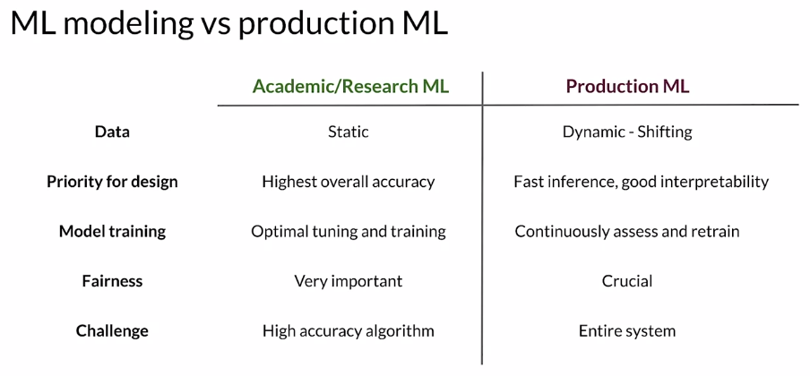

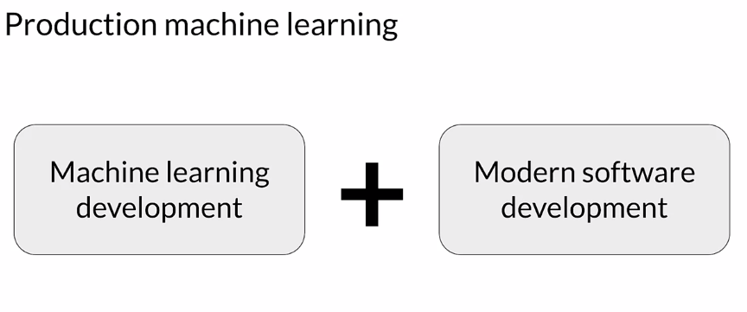

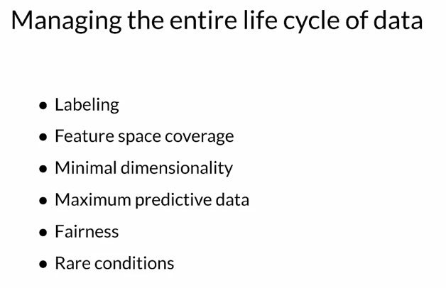

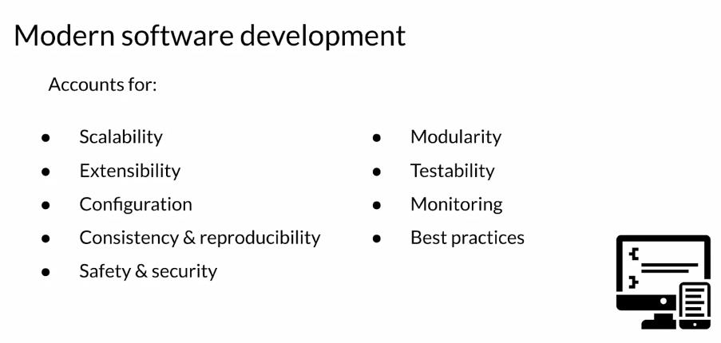

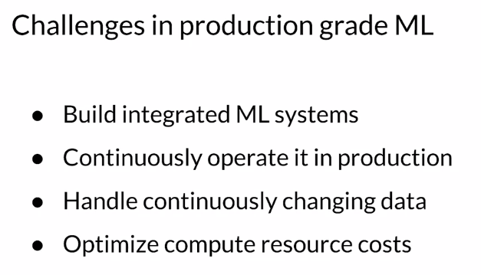

### ML Pipelines

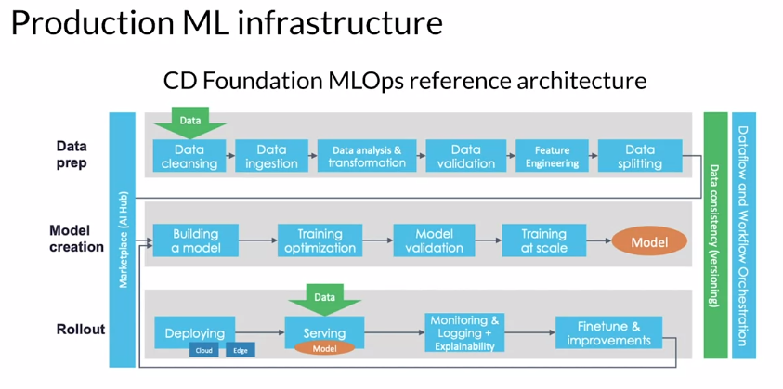

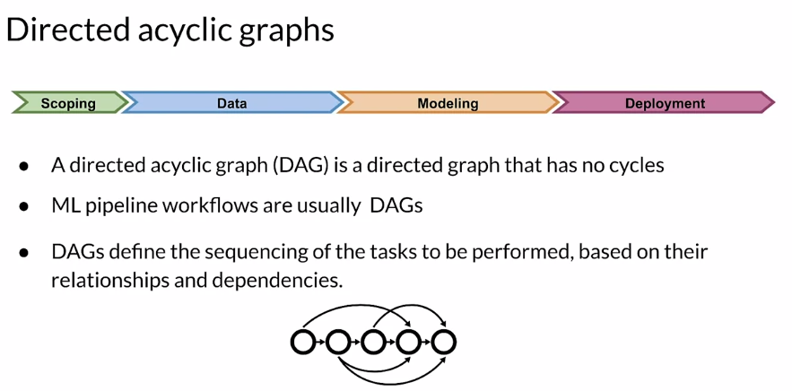

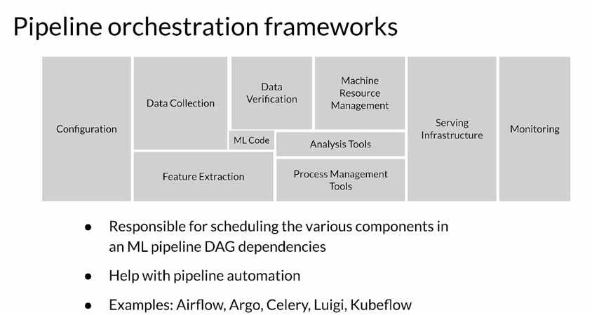

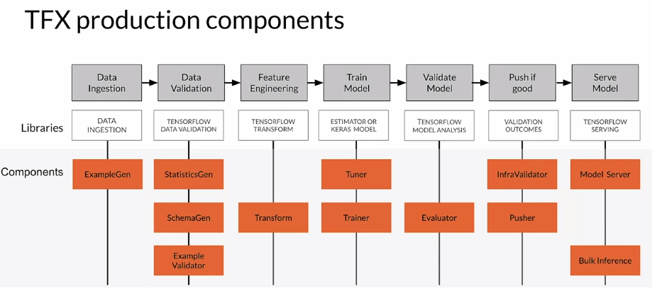

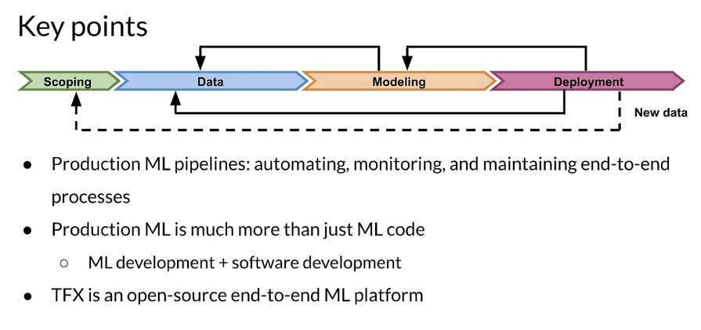

## Collecting Data

### Importance of Data

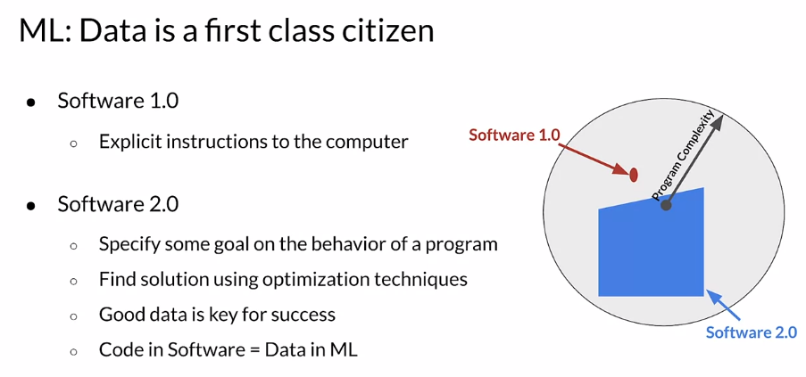

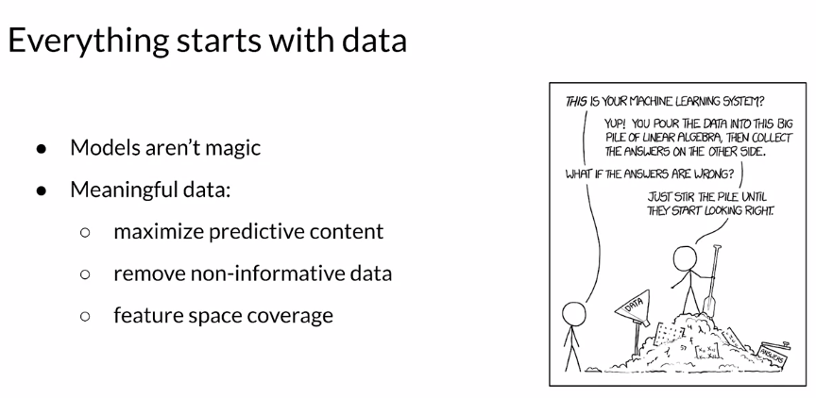

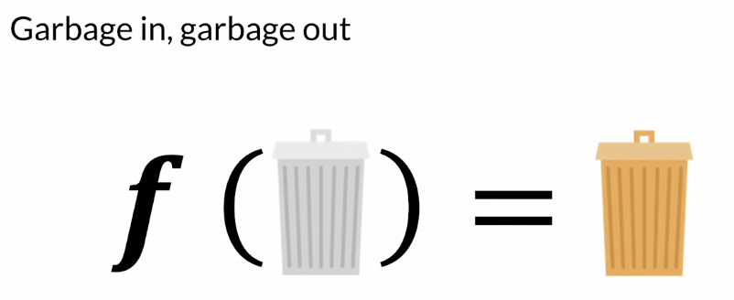

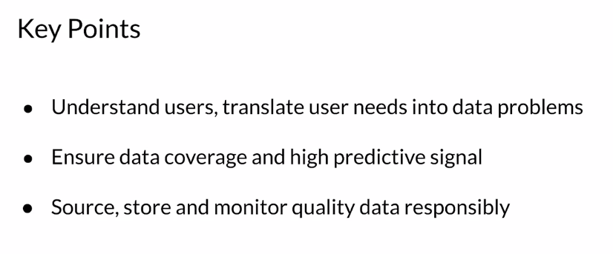

### Example Application: Suggesting Runs

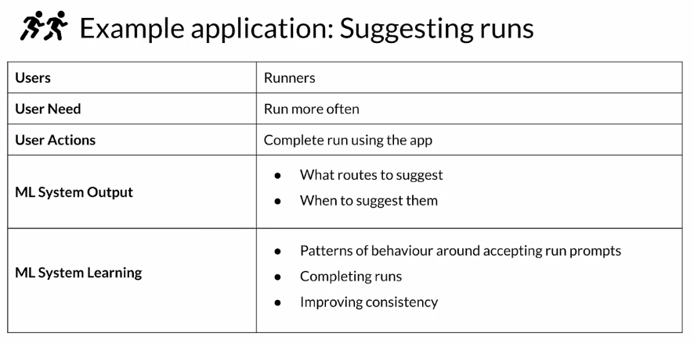

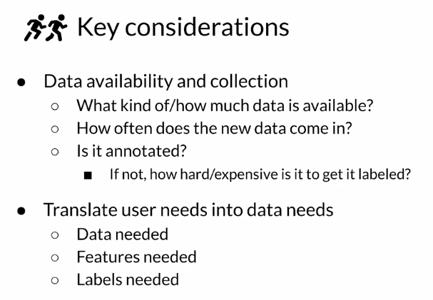

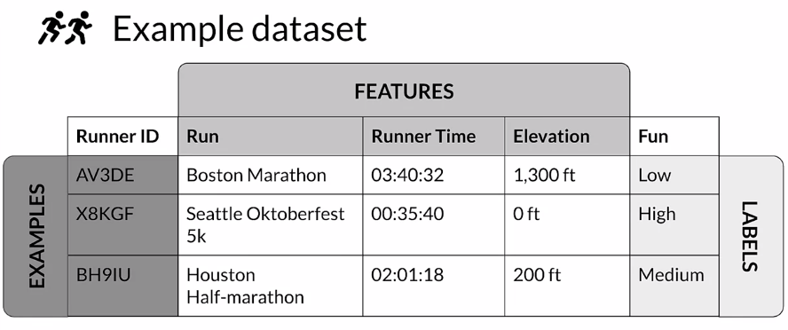

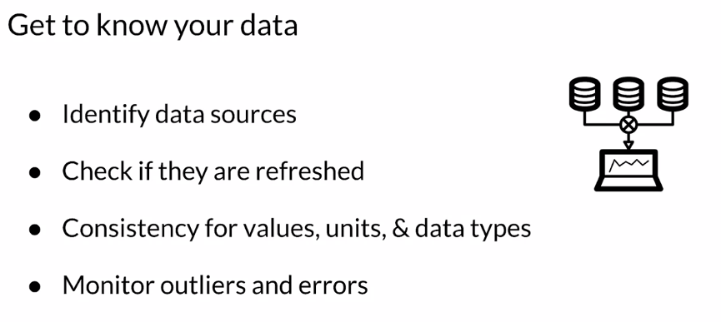

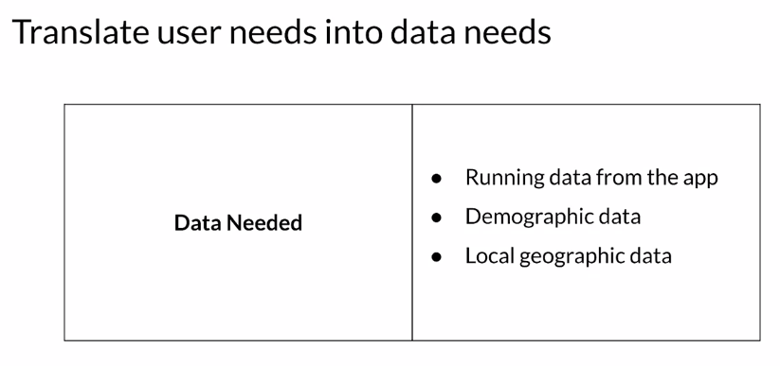

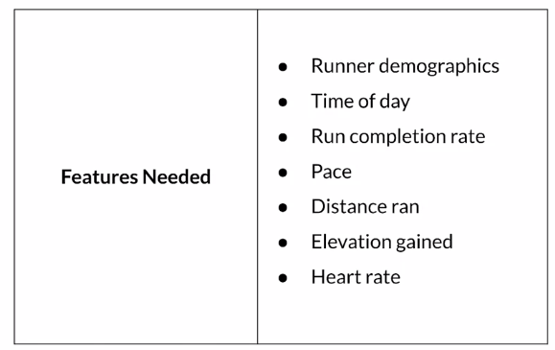

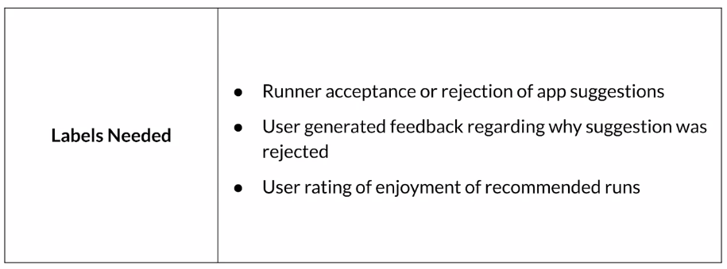

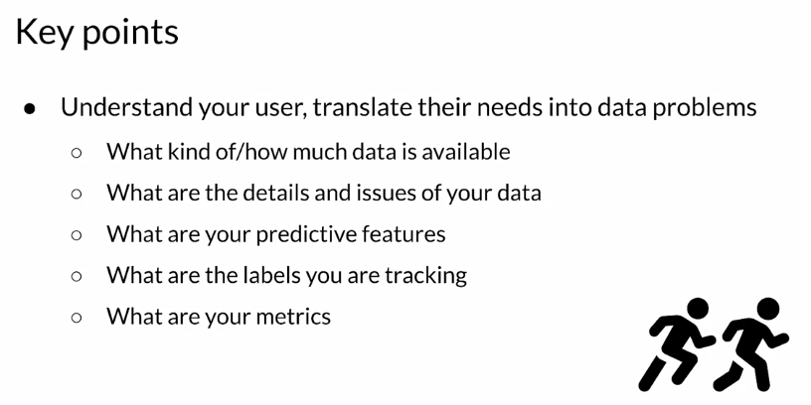

### Responsible Data: Security, Privacy & Fairness

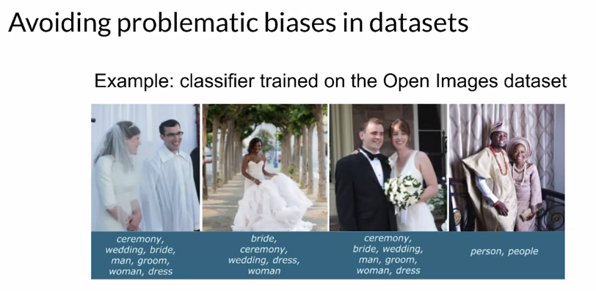

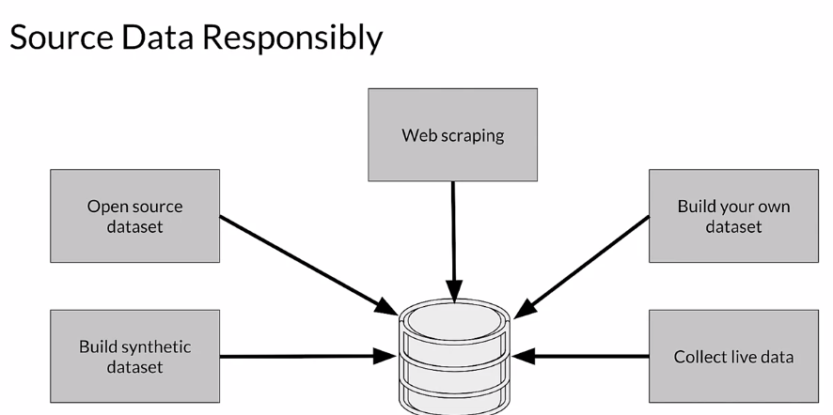

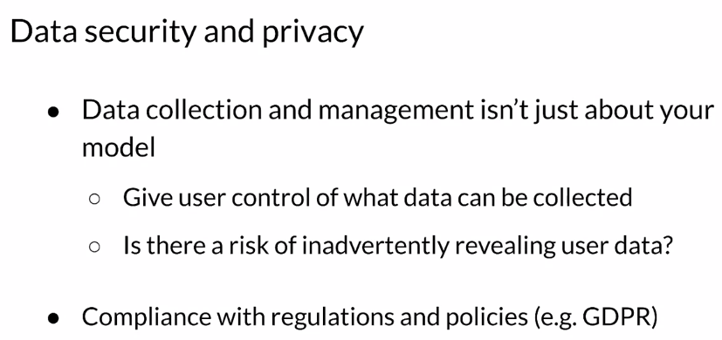

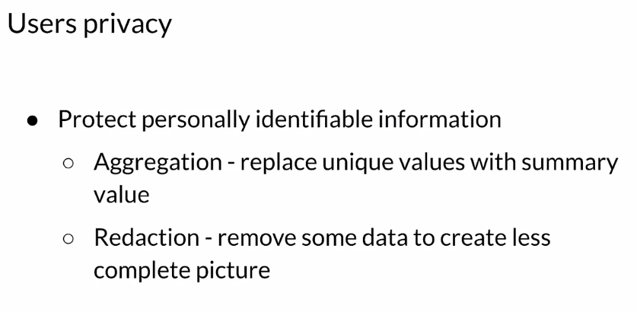

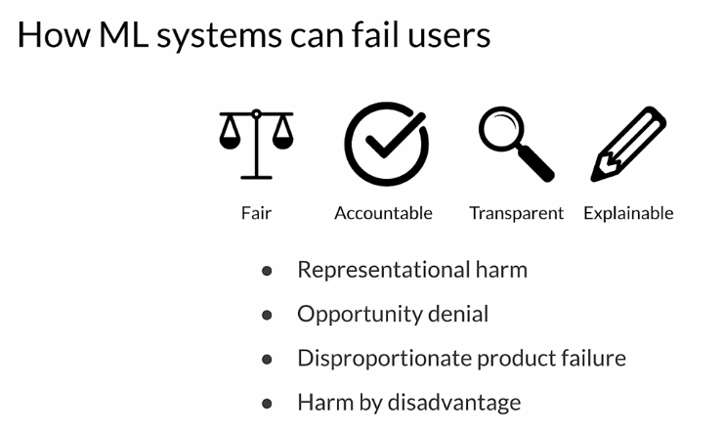

Some of the ways that ML Systems can fail are through things like representational harm. So **representational harm** is where a system will amplify or reflect a negative stereotype about particular groups. **Opportunity denial** is when a system makes predictions that have negative real life consequences that could result in lasting impacts. **Disproportionate product failure** is where the effectiveness of your model is really skewed so that the outputs happen more frequently for particular groups of users, you get skewed outputs more frequently essentially can think of as errors more frequently. **Harm by disadvantage** is where a system will infer disadvantageous associations between different demographic characteristics and the user behaviors around that.

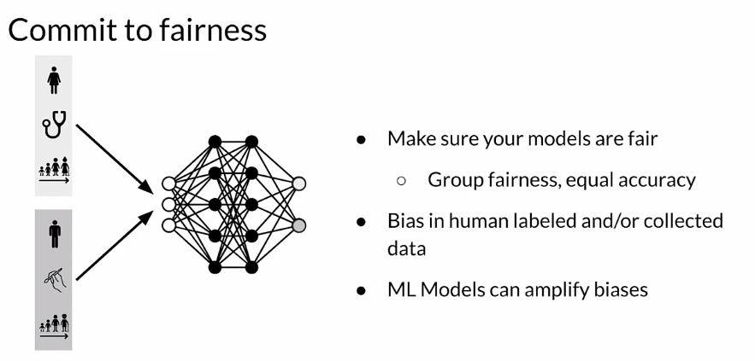

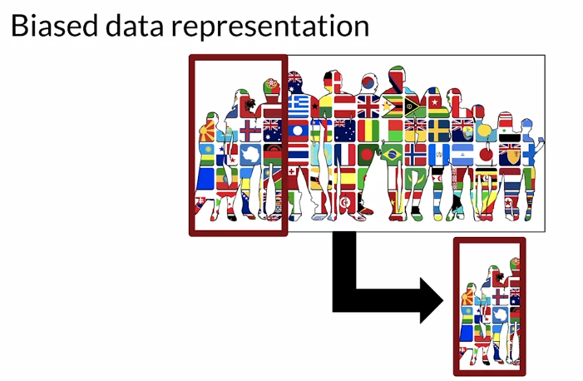

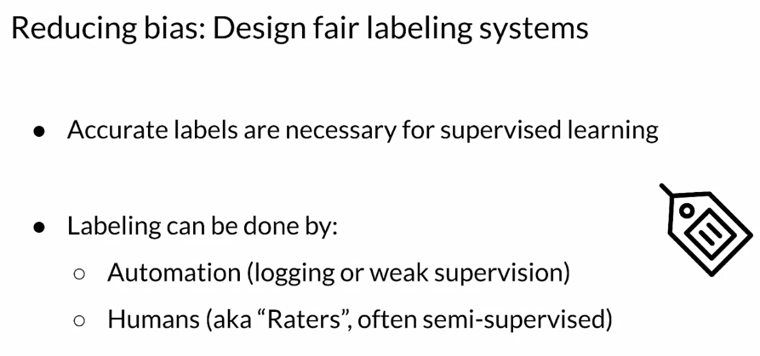

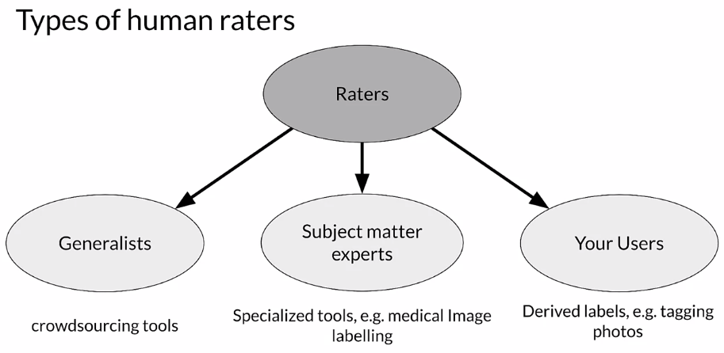

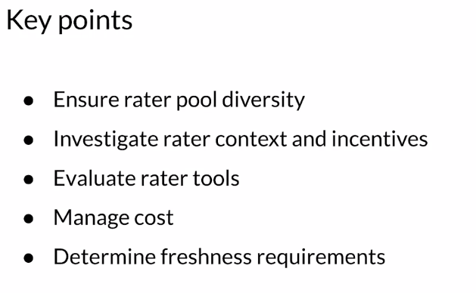

## Labeling Data

### Case Study: Degraded Model Performance

To illustrate some of the issues with labeled data in performance settings, let's take a look at a case study.

So imagine that you're an online retailer and you're selling shoes and you have a model that predicts click through rates which helps you to decide how much inventory to order.

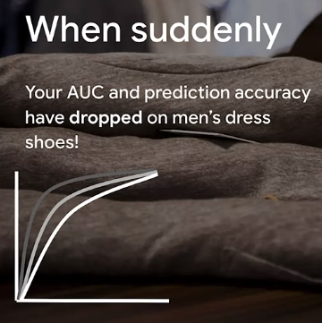

Why? You trained your model? You did fairly well in your metrics and so forth. Why is it different? What changed? Why does your model not predict men's dress shoes well now? And perhaps more importantly, how do you even know that you have a problem?

if you don't put good practices into place in the production setting, you're probably going to find out either when you order way too many shoes or not enough shoes. And that's not a situation that you want to be in in a business. This is going to cost you money.

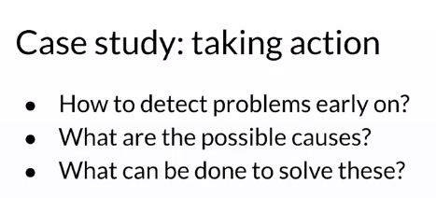

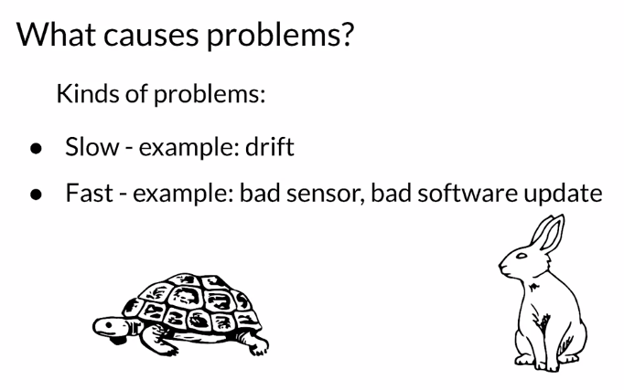

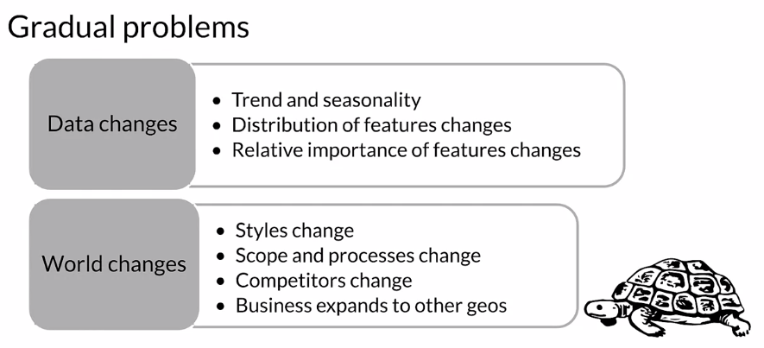

So, maybe last year black shoes were really fashionable for men's dress shoes and now it's brown shoes or what have you.

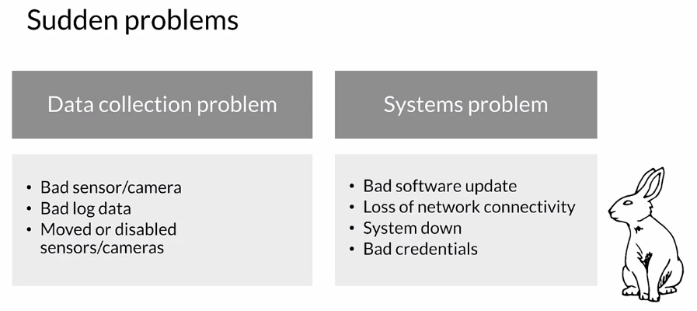

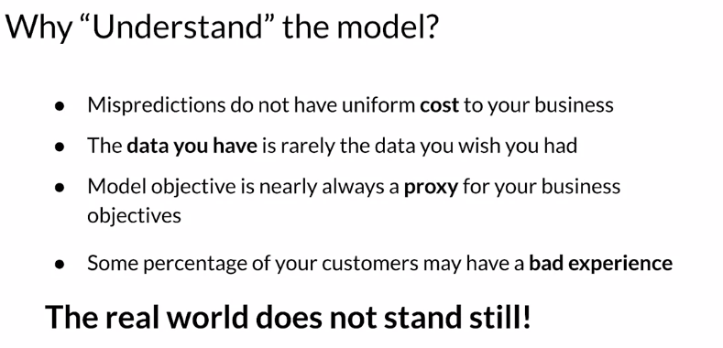

In the case of the shoes that we just looked at, we were predicting click through rates as a proxy for deciding how much inventory to order.

### Data and Concept Change in Production ML

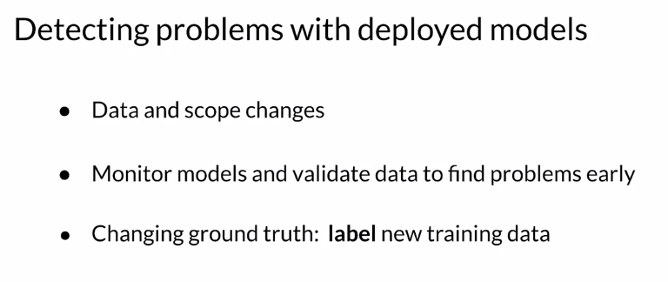

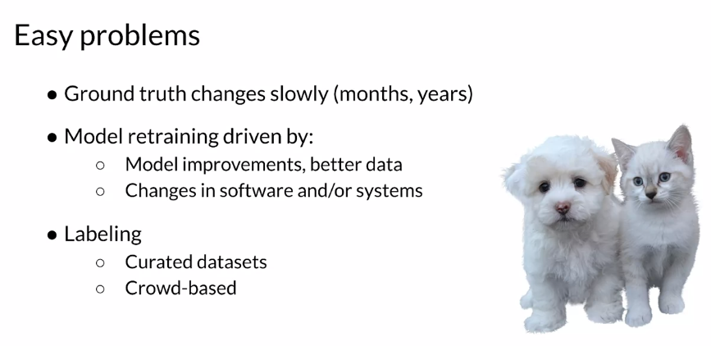

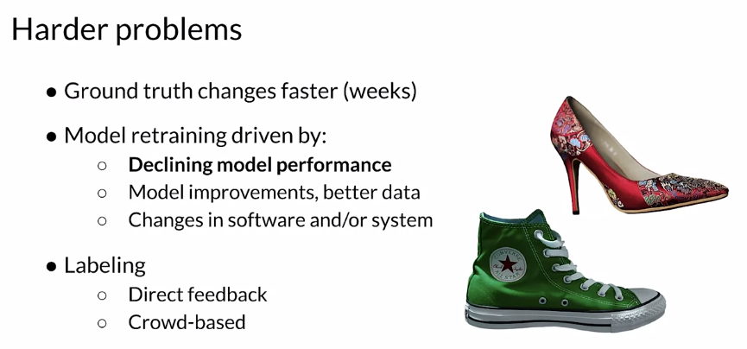

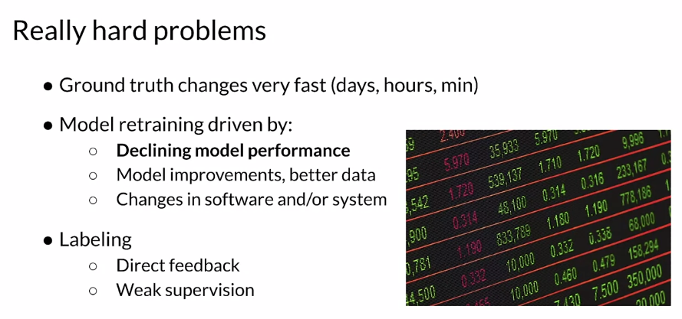

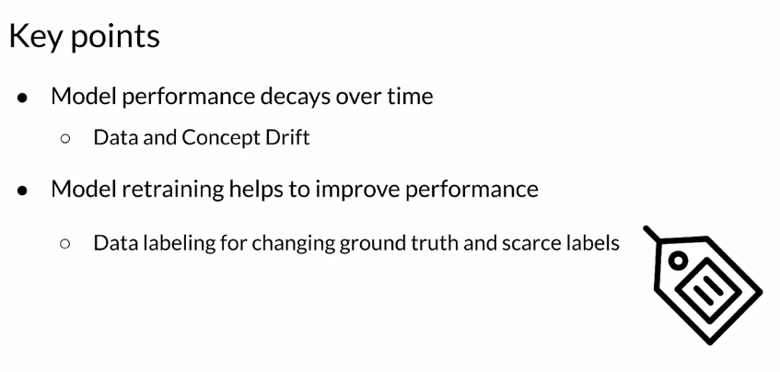

### Process Feedback and Human Labeling

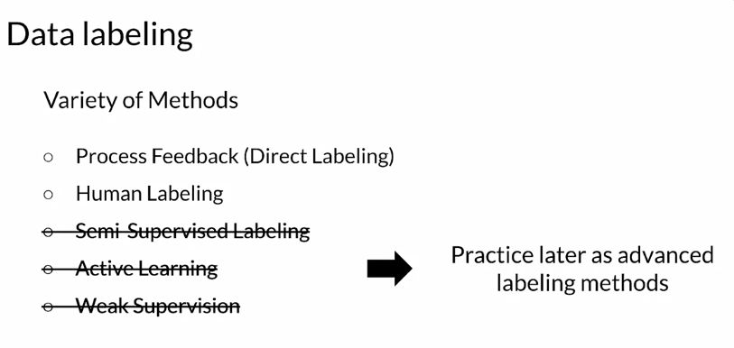

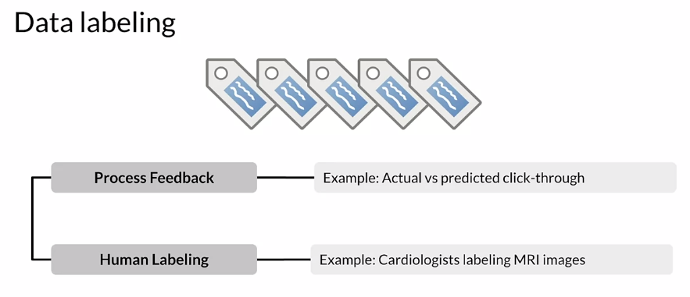

Actual versus predicted click-through rates. Suppose you have recommendations that you are giving to a user, did they actually click on the things that you recommend? If they did, you can label it positive, if they didn't you can label it negative. Human labeling, you can have humans look at data and apply labels to them. For example, you can ask cardiologists to look at MRI images and apply labels to them.

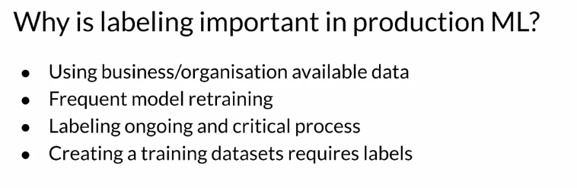

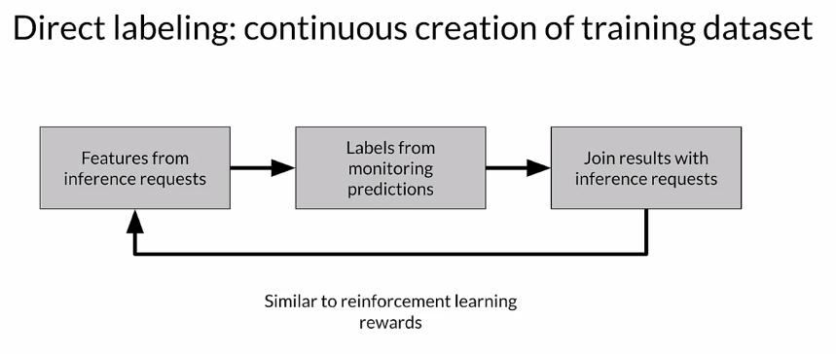

Labeling is an ongoing and often critical process in your application and your business. But at the end of the day, creating a training data set for supervised learning requires labels, you need to think about how you're going to do that. **Direct labeling**, which we'll talk about first or process feedback, is a way of continuously creating new training data that you're going to use to retrain your model. You're taking the features themselves from the inference requests that your model is getting. The predictions that your model is being asked to make and the features that are provided for that. You get labels for those inference requests by monitoring systems and using the feedback from those systems to label that data. One of the things that you need to solve there is to join the results that you get from monitoring those systems with the original inference request which could be hours or days apart. You might've run batches on Monday and you're getting feedback on Friday. You need to make sure that you can do those joins to apply those labels. In some ways you can think about this as similar to reinforcement learning, where instead of applying rewards based on action you're applying labels based on a prediction.

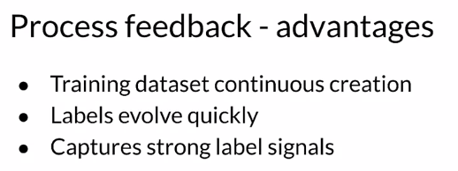

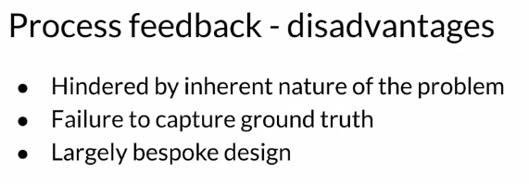

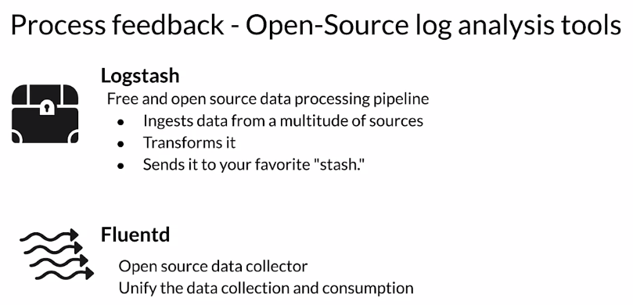

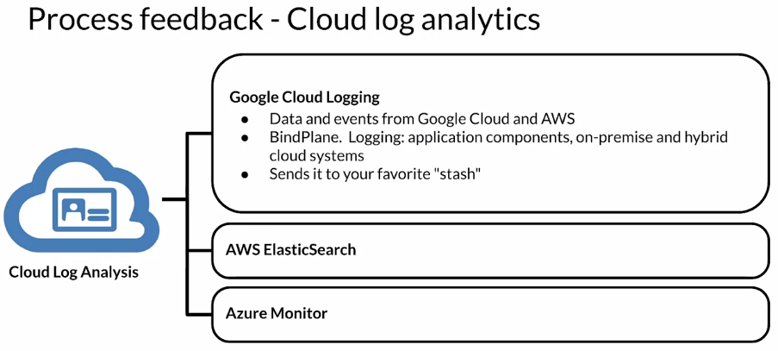

Now, let's turn to human labeling. In human labeling, you have people, humans and we refer to those as raters. We ask them to examine data and assign labels to it. It sounds simple, it sounds like it might be painful but it's the way that a lot of data is generated and labeled. You start with raw data and you give it to people and you ask them to apply labels to it. That's the way that you create a training data set that you're going to use to train or retrain your model.

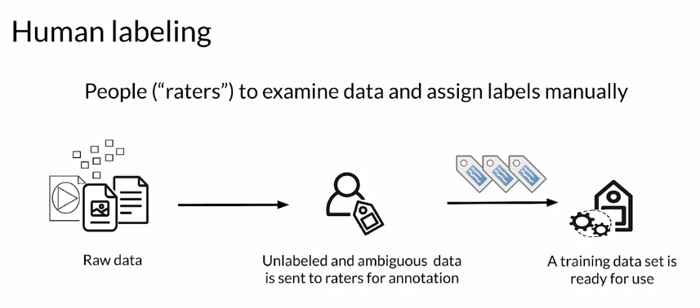

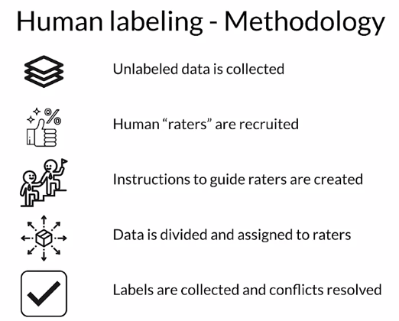

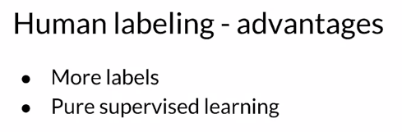

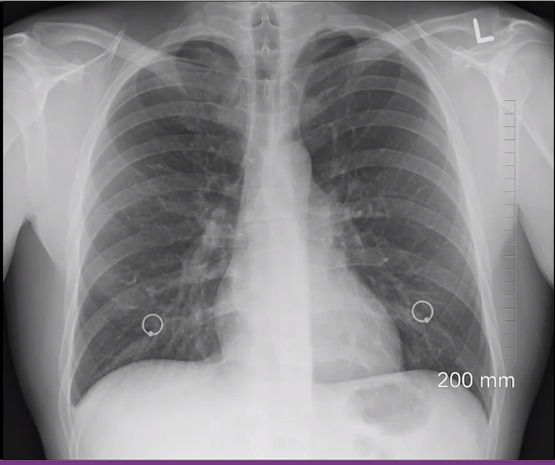

One disadvantage, one issue here is that depending on the data that you have it can be very complex for a human to look at it and decide what the label should be. Something like this we might need a radiologist to look at this and tell us what the right labels should be which can be very expensive. But if you're also talking about situations where you have high dimensional data, it's very difficult for humans to look at, say, 100 different features and decide what the label is.

### 

### 

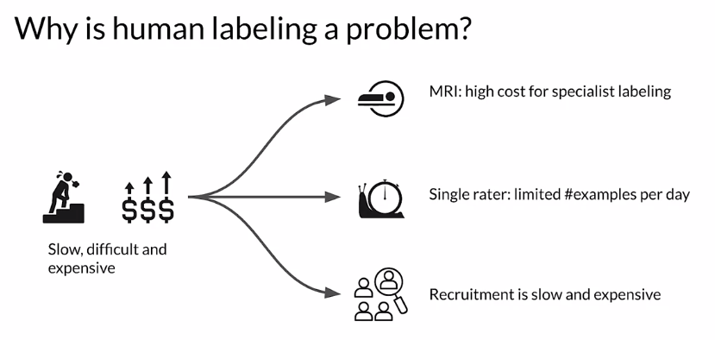

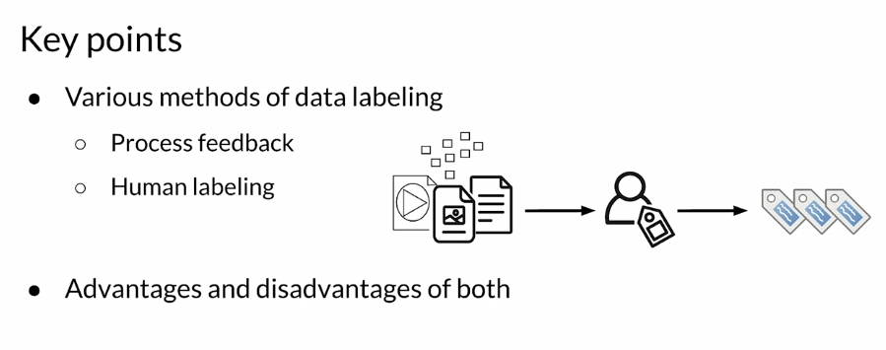

## Validating Data

### Detecting Data Issues

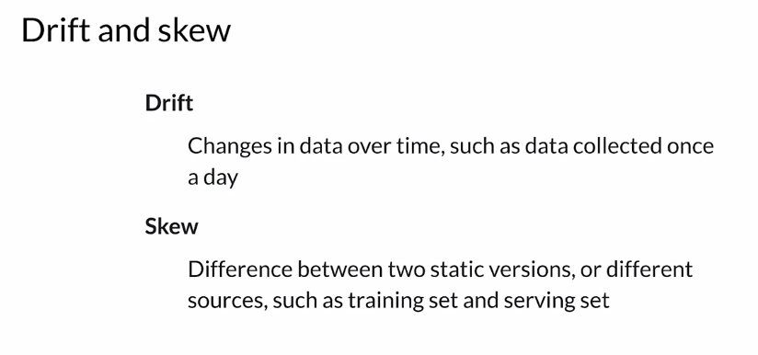

For example, it could be the difference between your training set and the data that you're getting for prediction requests, your serving set. Those differences are referred to as skew. In a typical ML pipeline, this shows batch processing, but it could also be online processing. You'll have different sources of data that are conceptually the same. They have the same feature vector, but over time they will change. That means that model performance can either drop quickly due to things like system failure or can decay over time due to changes in the data and things like changes in the world. We're going to focus on performance decay over time that arises due to issues between training and serving data. There's really two main reasons for that. There's **Data drift**, which are changes in the data between training and serving typically and Concept drift, which are changes in the world changes in the ground truth.

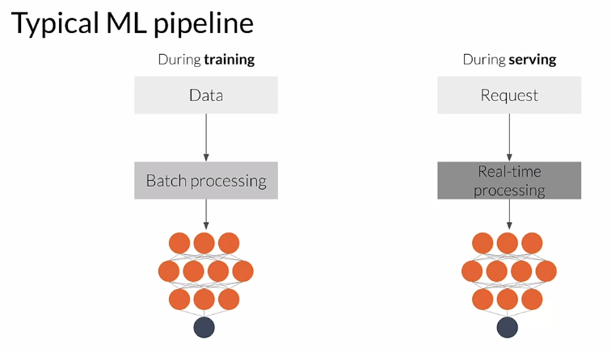

To understand model decay over time, an ML model will start to perform poorly in many cases and we refer to this as model decay. That's usually or often caused by drift, which is, changes in a conceptual way. There is, changes in the statistical properties of the features. It's sometimes due to things like seasonality or trend or unexpected events, or just changes in the world. This example, here, we're looking at an app that during trainin,g the app classified as a spammer, any user who is sending 20 or more messages per minute. We classified anybody like that as a spammer. But after a system update which you see as labeled on the chart there, both spammers and non-spammers start to send more messages. In this case, the data, the world has changed and that causes unwanted misclassification. We have all of our users classified as spammers which they probably won't like.

# 

Concept drift is a change in the statistical properties of the labels over time. At training, an ML model learns a mapping between the features and the labels. In a static world that's fine, that won't change. But in the real-world, distribution and the labels meaning will change. The model needs to change as well as the mapping found during training will no longer be valid.

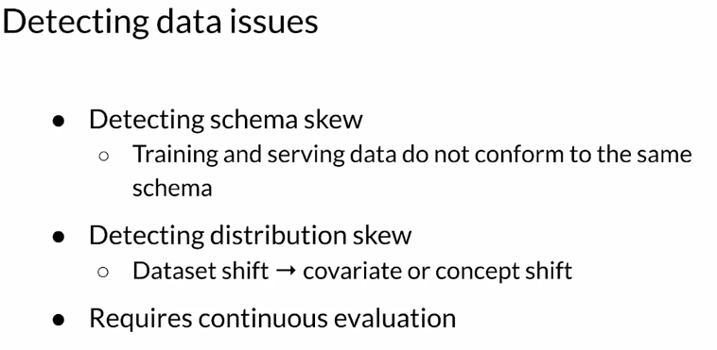

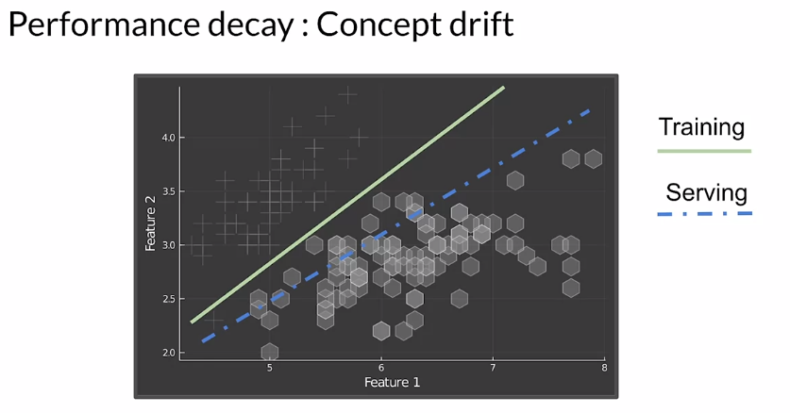

Let's take a look at a more rigorous definition of the drift and skew that we're talking about. **Dataset shift** occurs when the joint probability of x are features and y are labels is not the same during training and serving. The data has shifted over time. **Covariate shift** refers to the change in distribution of the input variables present in training and serving data. In other words, it's where the marginal distribution of x are features is not the same during training and serving, but the conditional distribution remains unchanged. **Concept shift** refers to a change in the relationship between the input and output variables as opposed to the differences in the Data Distribution or input itself. In other words, it's when the conditional distribution of y are labels given x are features is not the same during training and serving, but the marginal distribution of x are features remains unchanged.

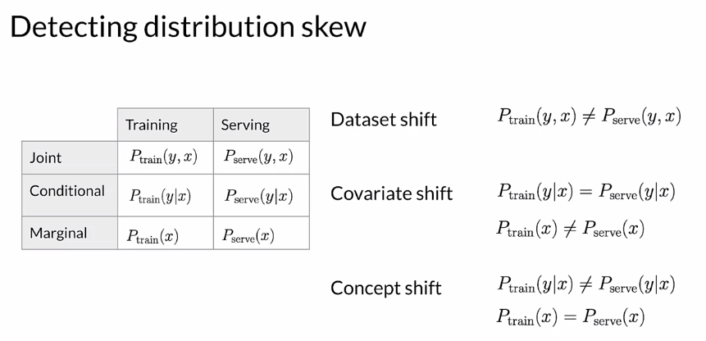

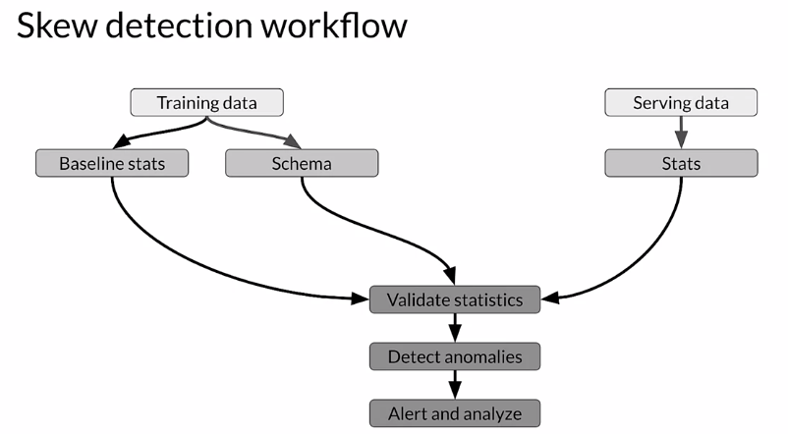

There's a straightforward workflow to detect data skew. The first stage is looking at training data and computing baseline statistics and a reference schema. Then you do basically the same with your serving data, you're going to generate the descriptive statistics. Then you compare the two. You compare your serving baseline statistics and instances. You check for differences between that and your training data. You look for skew and drift. Significant changes become anomalies and they'll trigger an alert. That alert goes to whoever's monitoring system, that can either be a human or another system to analyze the change and decide on the proper course of action. That's got to be the remediation of the way that you're going to fix and react to that problem.

### TensorFlow Data Validation

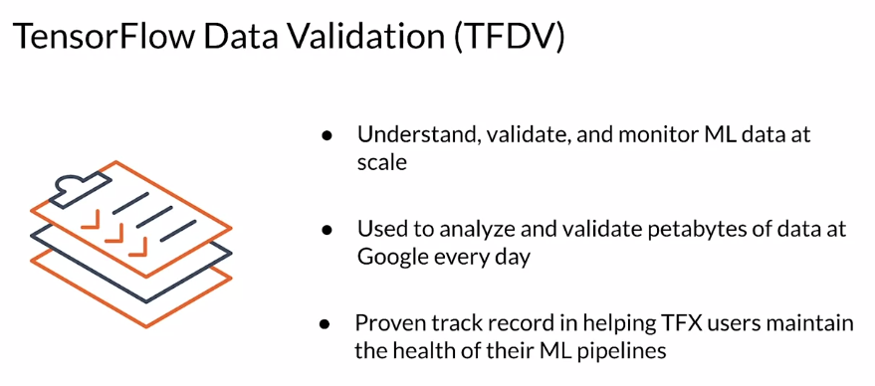

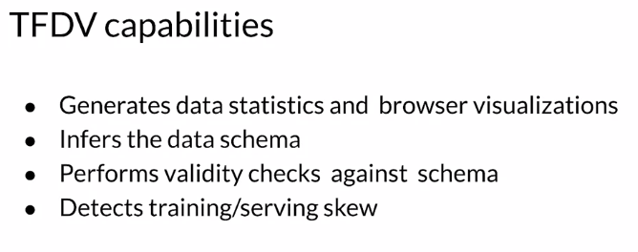

#### 

#### 

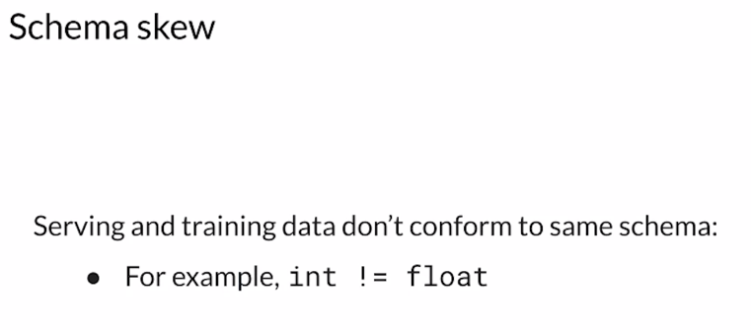

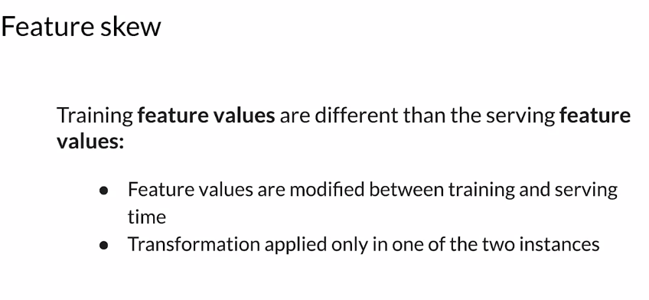

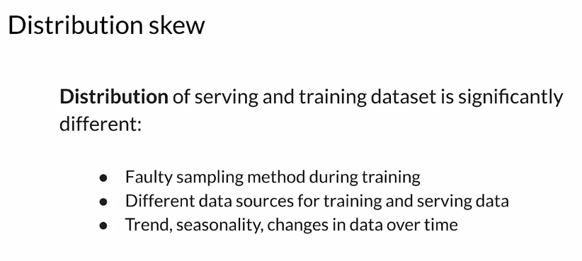

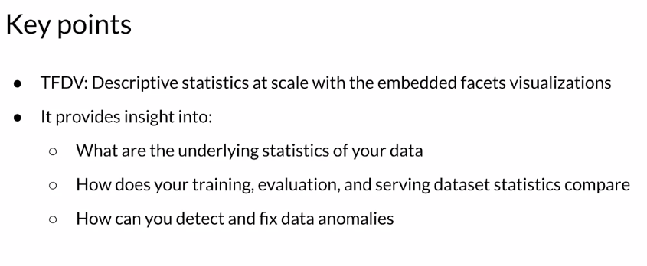

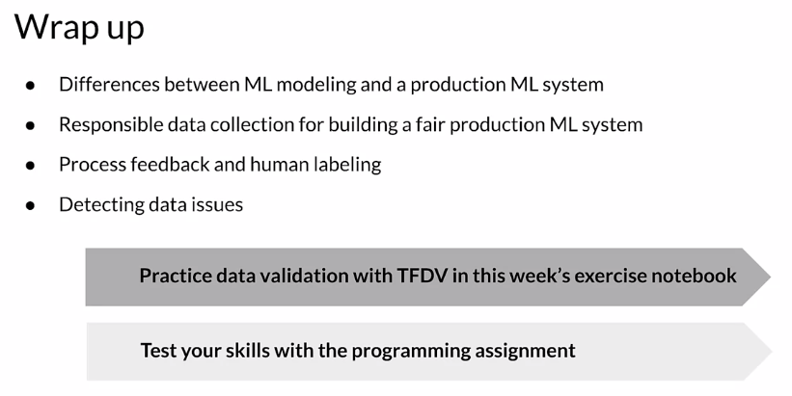

## Week 1 Optional References

Week 1: Collecting, Labeling and Validating Data

This is a compilation of optional resources including URLs and papers appearing in lecture videos. If you wish to dive more deeply into the topics covered this week, feel free to check out these optional references. You won’t have to read these to complete this week’s practice quizzes.

[MLops](https://cd.foundation/blog/2020/02/11/announcing-the-cd-foundation-mlops-sig/)

[Data 1st class citizen](https://medium.com/@karpathy/software-2-0-a64152b37c35)

[Runners app](https://pair.withgoogle.com/chapter/data-collection/)

[Rules of ML](https://developers.google.com/machine-learning/guides/rules-of-ml)

[Bias in datasets](https://ai.googleblog.com/2018/09/introducing-inclusive-images-competition.html)

[Logstash](https://www.elastic.co/logstash)

[Fluentd](https://www.fluentd.org/)

[Google Cloud Logging](https://cloud.google.com/logging/)

[AWS ElasticSearch](https://aws.amazon.com/elasticsearch-service/)

[Azure Monitor](https://azure.microsoft.com/en-us/services/monitor/)

[TFDV](https://blog.tensorflow.org/2018/09/introducing-tensorflow-data-validation.html)

[Chebyshev distance](https://en.wikipedia.org/wiki/Chebyshev_distance)

Papers

Konstantinos, Katsiapis, Karmarkar, A., Altay, A., Zaks, A., Polyzotis, N., … Li, Z. (2020). Towards ML Engineering: A brief history of TensorFlow Extended (TFX).<http://arxiv.org/abs/2010.02013>

Paleyes, A., Urma, R.-G., & Lawrence, N. D. (2020). Challenges in deploying machine learning: A survey of case studies.<http://arxiv.org/abs/2011.09926>

ML code fraction:

Sculley, D., Holt, G., Golovin, D., Davydov, E., & Phillips, T. (n.d.). Hidden technical debt in machine learning systems. Retrieved April 28, 2021, from Nips.cc<https://papers.nips.cc/paper/2015/file/86df7dcfd896fcaf2674f757a2463eba-Paper.pdf>

### 

# Week 2: Feature Engineering, Transformation and Selection

## Feature Engineering

### Introduction to Preprocessing

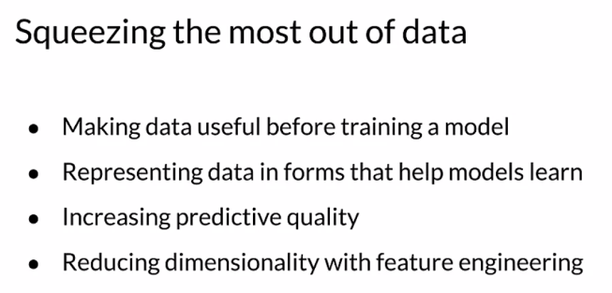

The art of feature engineering tries to improve your model's ability to learn while reducing, if possible, the compute resources it requires. It does this by transforming and projecting, eliminating and or combining the features in your raw data to form a new version of your data set. So typically across the ML pipeline, you incorporate the original features often transformed or projected to a new space and or combinations of your features.

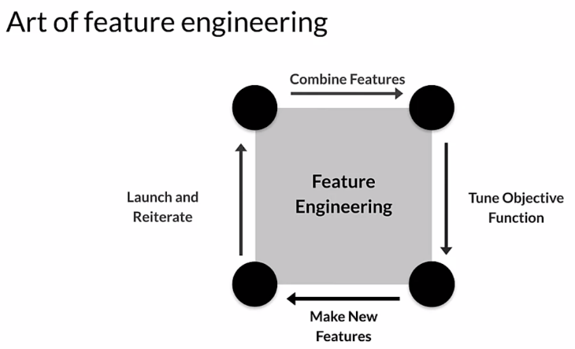

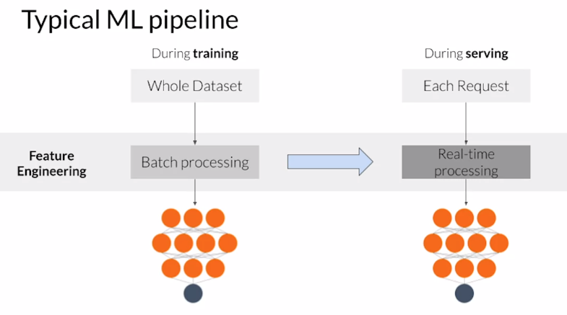

Feature engineering is usually applied in two fairly different ways, during training, you usually have the entire data set available to you. So you can use global properties of individual features in your feature engineering transformations. For example, you can compute the standard deviation of a feature and then use that to perform normalization. However, when you serve your trained model, you must do the same feature engineering so that you give your model the same types of data that it was trained on. For example, if you created a one hot vector for a categorical feature when you trained, you need to also create an equivalent one hot vector when you serve your model. However, during training and serving, you typically process each request individually, so it's important that you include global properties of your features, such as the standard deviation. If you use it during training include that with the feature engineering that you do when serving, failing to do that right is a very common source of problems in production systems, and often these errors are difficult to find.

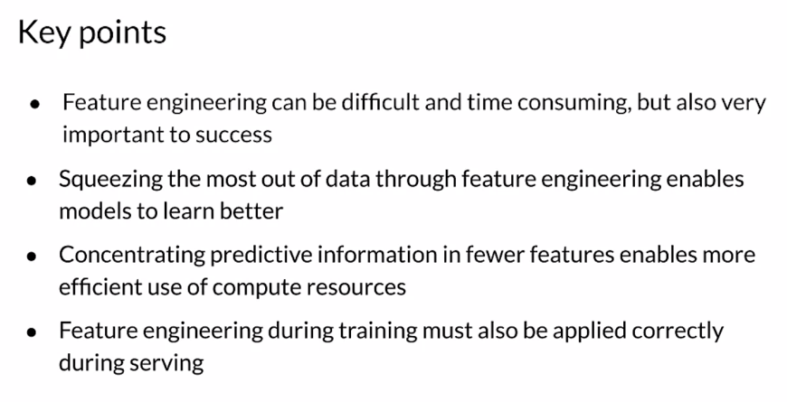

### Preprocessing Operations

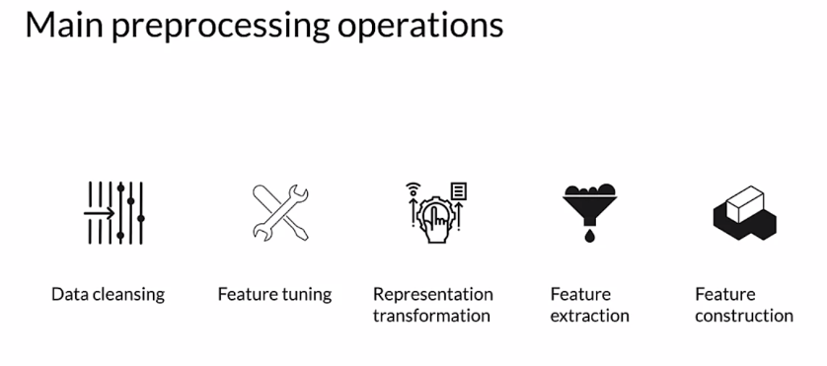

One of the most important Preprocessing Operations is **Data cleansing**, which in broad terms consists in eliminating or correcting erroneous data. You'll often need to perform **Transformations** on your data, so scaling or normalizing your numeric values, for example. Since models, especially neural networks, are sensitive to the amplitude or range of numerical features, data preprocessing helps Machine Learning build better predictive models. **Dimensionality Reduction** involves reducing the number of features by creating lower dimension and more robust data representations. **Feature Construction** can be used to create new features by using several different techniques, which we'll talk about some of them.

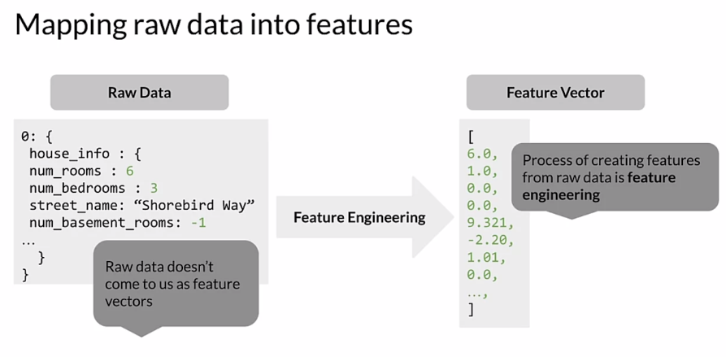

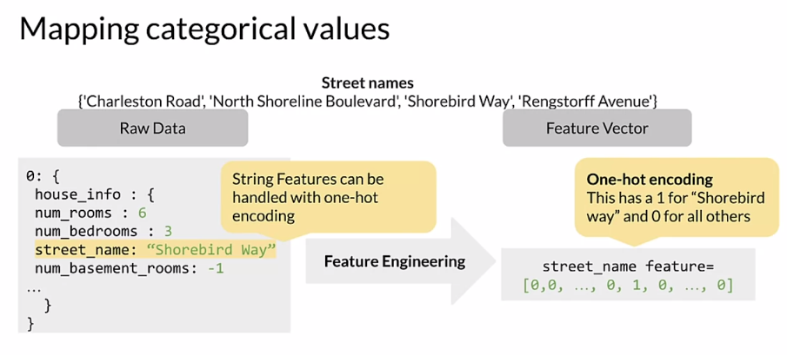

Tensorflow provides three different functions for creating columns of categorical vocabulary and other frameworks do very similar things. A categorical column with vocabulary lists maps each string to an integer based on an explicit vocabulary list. Feature name is a string which corresponds to the categorical feature and vocabulary list is an ordered list that defines vocabulary. Feature or categorical column with a vocabulary file very similar from a file is used when you have two long lists and this function allows you to put the words in a separate file. In this case, vocabulary list is defined as a file that will define the list of words. This is very typical for working with vocabularies.

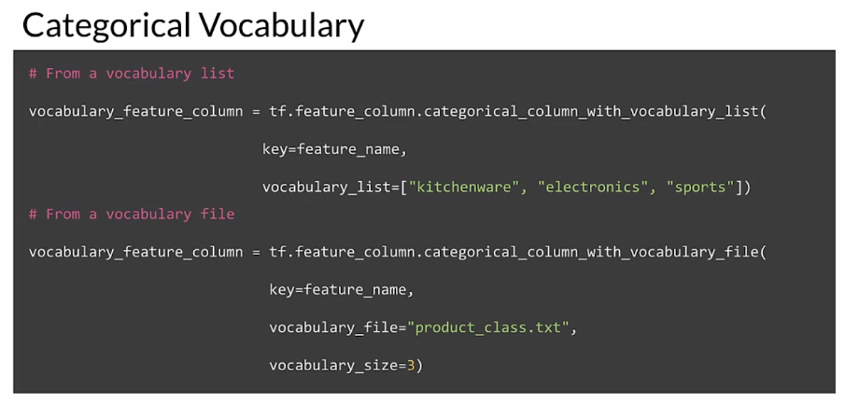

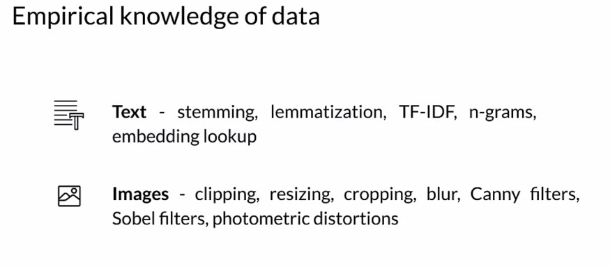

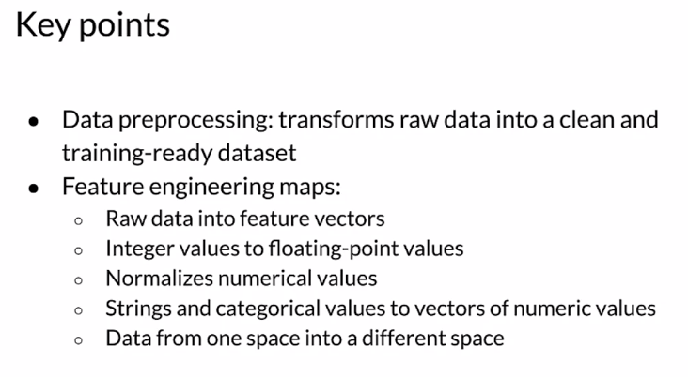

### Feature Engineering Techniques

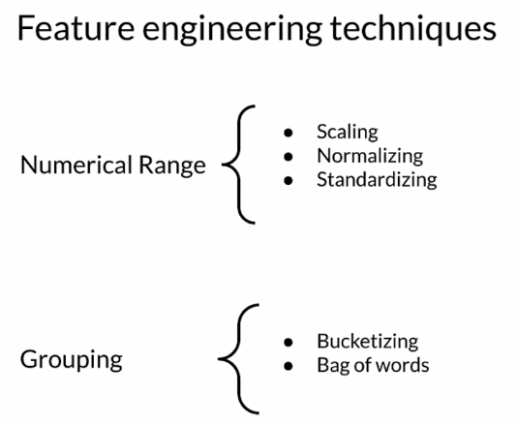

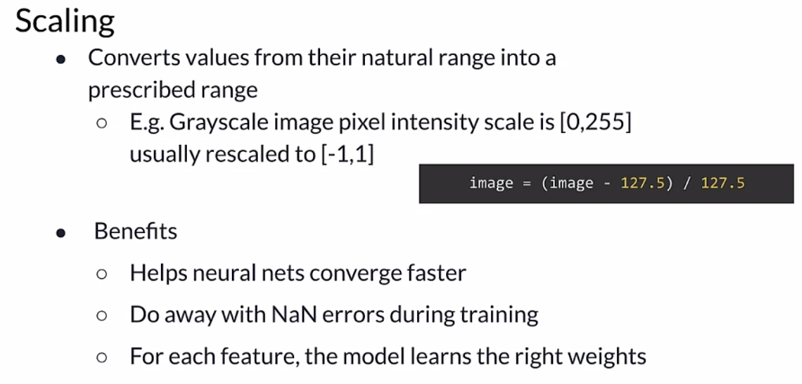

Normalizations are usually good if you know that the distribution of your data is not Gaussian. Doesn't always have to be true, but typically that's a good assumption to start with. A good rule of thumb. If you're working with data that you know is not Gaussian, or a normal distribution, then normalization is a good technique to start with. Normalization is widely used for scaling, you have a numerical feature that might start out like this, where numbers are falling and there is a kind of a range. You're going to transform that to the normalized version of that, which is bounded in a range between 0-1.

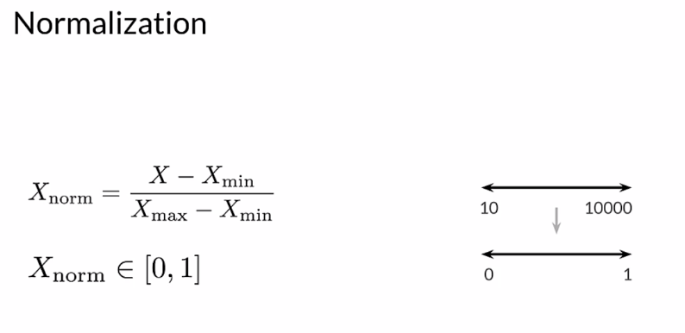

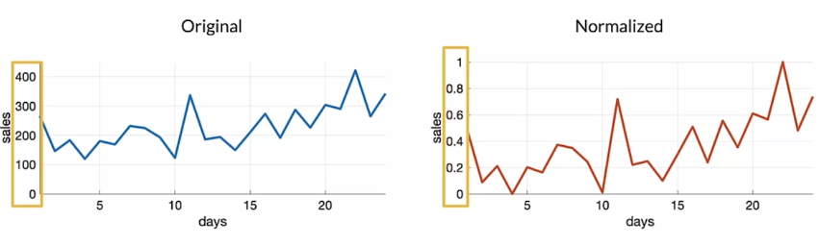

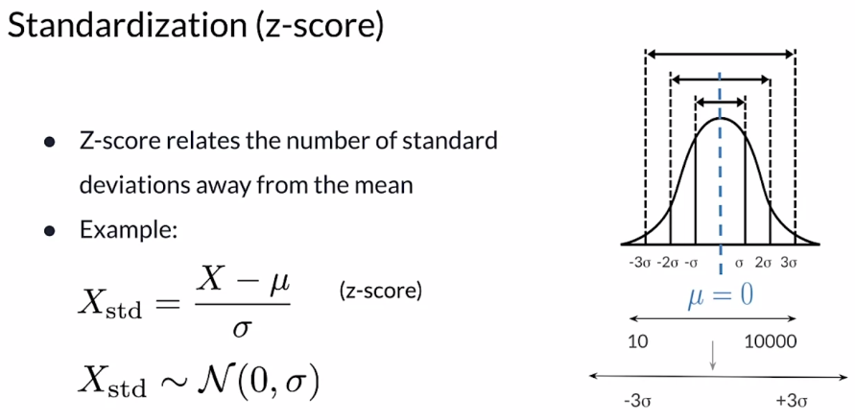

Standardization, which is often using a Z-score, is a different technique. It's a way of scaling using the standard deviation. It's looking at the distribution itself and trying to scale relative to that. The example here is using, , and you're going to subtract the mean and divide by the standard deviation. That gives you the Z- score or the standardized value of X. Which is somewhere between zero and the standard deviation. This is how that's expressed, actually between some multiple of the standard deviation. But it's centered around the mean of the data. If the original looked like this, again, a standardized value of that might look like this. Notice that this score is centered on zero, so the mean is translated to zero. But you can have negative values and positive values that are beyond one. It's a little bit less bounded transformation than a normalization is. But there are some advantages to it, that your data is a normal distribution, then a standardization technique is a good place to start, it's a good rule of thumb to start with for your numerical features. But I encourage you to try both standardization and normalization and compare the results. Because sometimes it doesn't make much of a difference. Sometimes it can make a substantial difference. It's good to try both.

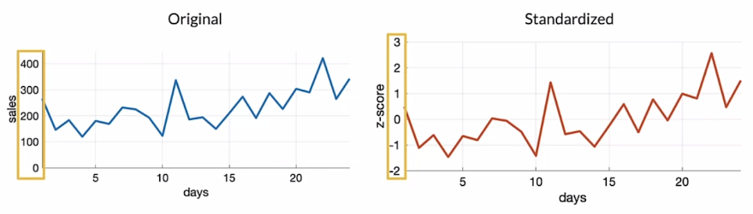

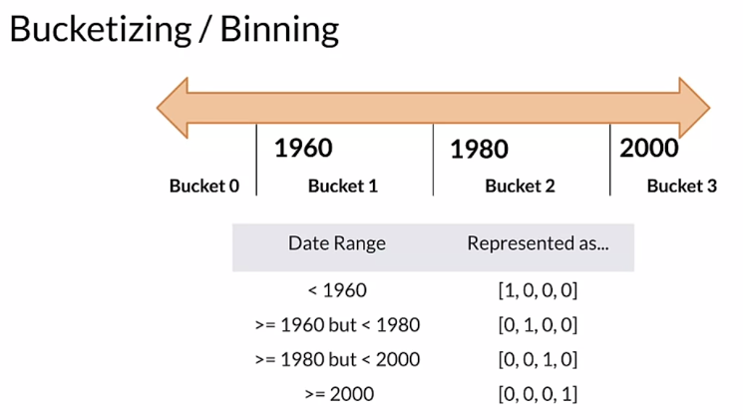

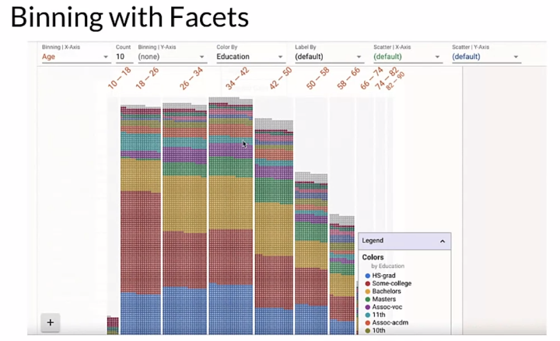

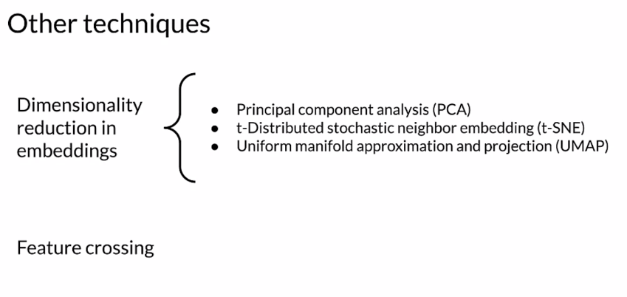

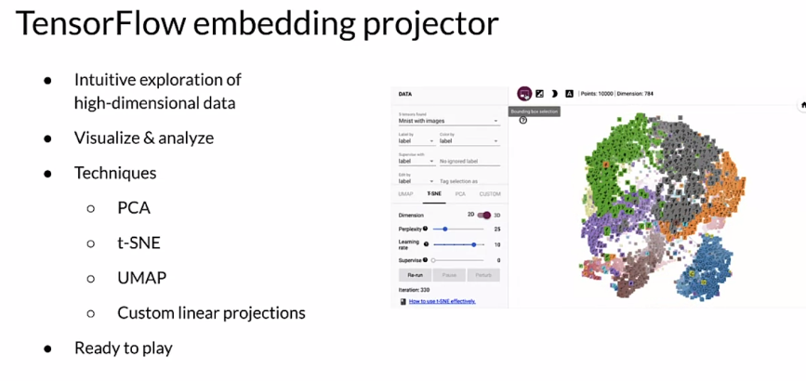

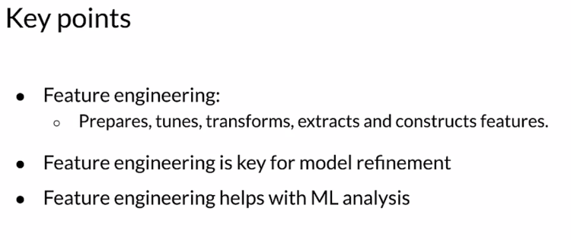

#### 

#### 

#### 

#### 

#### 

#### 

#### 

#### 

### Feature Crosses

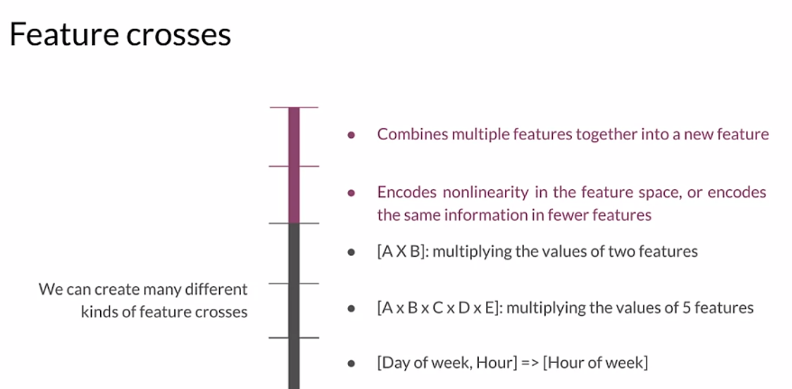

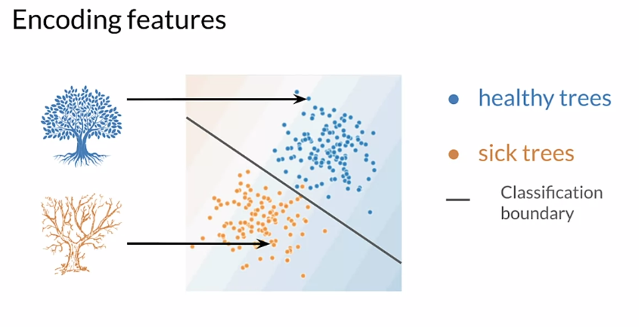

We're going to use a scatter-plot to try to understand our data. We're looking at the scatter plot and we use some visualization tools, and we ask ourselves, can we draw a line to separate these two groups, these two clusters? If we can use a line to create the decision boundary, then we know that we can use a linear model. That's great. In this case, looking at this, we could use a line to do that separation. That's great. Linear models are very efficient. We love that, but let's suppose the data looks like this. Not so easy anymore. This becomes a non-linear program. Then the question is, can we project this data into a linear space and use it with a linear model, or do we have to use a non-linear model to work with this data? Because if we try to draw just a linear classification boundary with the data as is, it doesn't really work too great. Again, we can use visualization tools to help us understand this. Looking at our data really helps inform us and guide the choices that we make as developers about what kind of models we choose and what feature engineering we apply. Key points here, Feature Crossing as a way to create synthetic features, often encoding non-linearity in the features space. We're going to transform both categorical and numerical. We could do that in, into either continuous variables or the other way around.

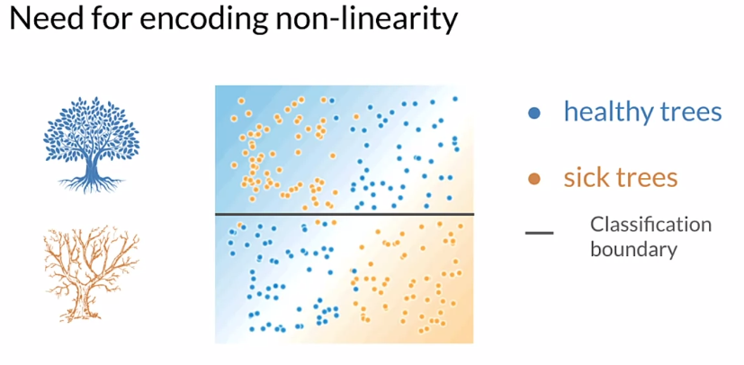

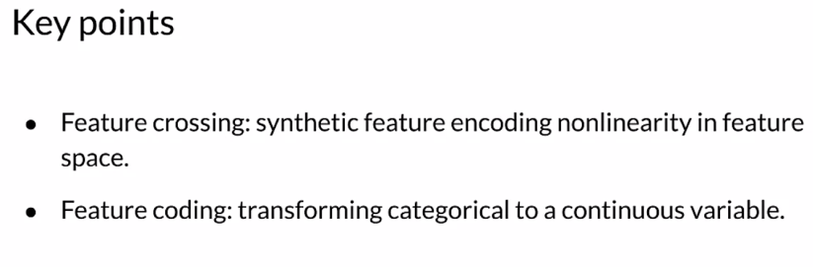

## Feature Transformation at Scale

### Preprocessing Data at Scale

We were developing our notebooks in python and then when we deployed into storm we had to translate all of the feature engineering that we did into java. Well, as you can imagine, that was not ideal and there were little weird problems that cropped up often very difficult to find doing that transformation. This is not an ideal way to do production machine learning.

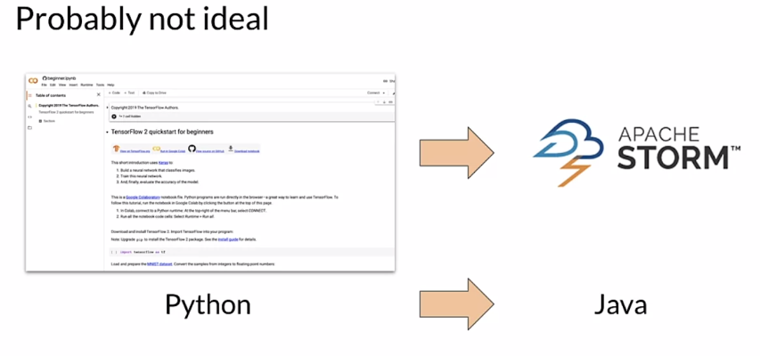

So what is a much better technique is to use a pipeline, a unified framework where you can both train and deploy with consistent and reproducible results.

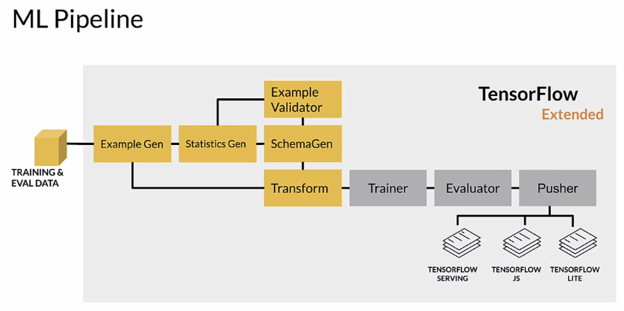

But there's a number of challenges that you need to deal with. So to preprocessed data at scale, we start with real world models and these could be terabytes of data. So when you're doing this kind of kind of work, you want to start with a subset of your data work out. As many issues as you can think about how that's going to scale up to the terabytes that you need to actually work with your whole dataset. Large scale data processing frameworks are no different than what you're going to use, on your laptop or in a notebook or what have you. So you need to start thinking about that from the beginning of the process, how this is going to be applied and the earlier you can start working with those frameworks. The more you work out the issues early with smaller datasets and quicker turnaround time, consistent transformations between training and serving are incredibly important. If you do different transformations when you're serving your model than you did when you were training your model, you are going to have problems and often those problems are very hard to find.

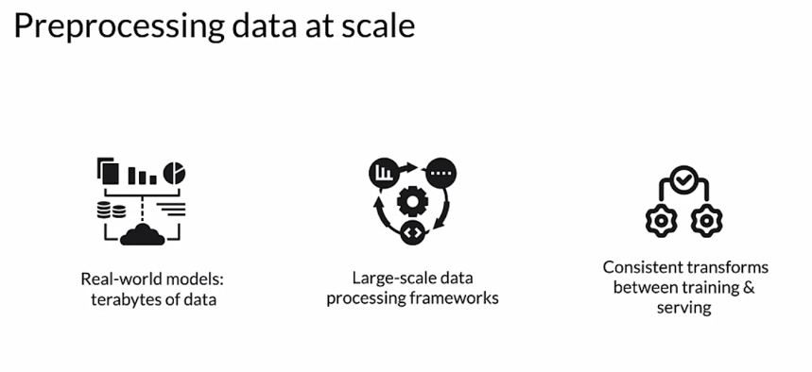

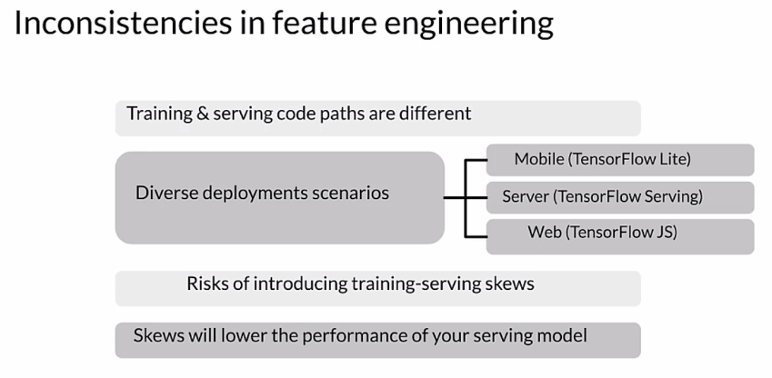

So there is a notion of the granularity at which you're doing preprocessing. So you need to think about this, you're going to do transformations, both the instance level and a full pass over your data. And depending on the transformation that you're doing, you may be doing it in one or the other. You can usually always do instance level. But a full path requires that you have the whole dataset. So for clipping, even for clipping, you need to set clipping boundaries. If you're not doing that through some arbitrary setting of those boundaries, if you're using the data set itself to determine how to clip, then you're going to need to do a full pass. So min max for clipping is going to be important. Doing a multiplication at the instance level is fine, but scaling well now I'm going to need probably the standard deviation and maybe the min and max. Bucketizing similarly, unless I know ahead of time what buckets are going to be, I'm going to need to do a full pass to find what buckets make sense. Expanding features I can probably do that at the instance level. So these two things are different at training time. I have the whole dataset so I can do a full pass, although it can be expensive to do that. At serving time, I get individual examples, so I can only really do instance level. So anything I need to do that requires characteristics of the whole dataset. I need to have that saved off so I can use it at serving time.

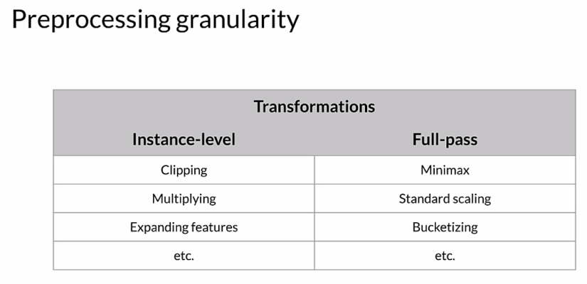

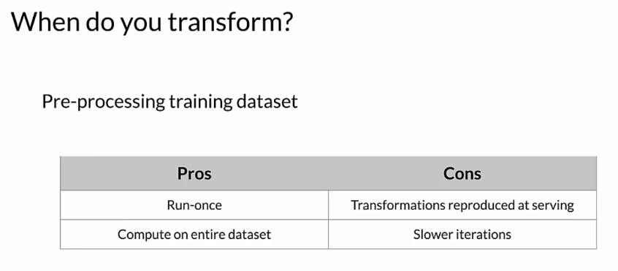

So when do you transform, you're going to pre-process your training dataset and there's pros and cons in how you do that. First of all, you don't you only run **once per training session**, so that's cool. And you're going to compute it on the entire dataset, but only once, for each training session. The cons: well, you're going to have to reproduce all those transformations that serve or save off the information that you learned about the data, like the standard deviation. So that you can use that later while you're serving. And there's, slower iterations around this. Each time you make a change, you've got to make a full pass over the dataset.

So you can do this **within the model**. Transforming within the model has some nice features so there are cons as well. First of all it makes iteration somewhat easier because it's embedded as part of your model and there's guarantees around the transformation that you're doing. But the cons are it can be expensive to do those transforms, especially when your compute resources are limited. And think about when you do a transform within the model, you're going to do that same transform at serving time. So you may have say GPUs or TPUs when you're training, you may not when you're serving. So there's long model latency, that's when you're serving your model, if you're doing a lot of transformation with it that can slow down the response time for your model and increase latency.And, you can have transformations per batch that skew that we talked about. If you haven't saved those constants that you need, that could be an issue.

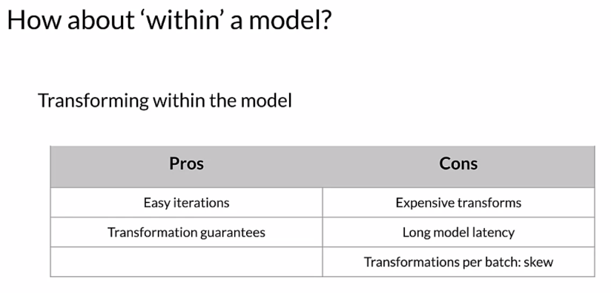

You can also **transform per batch** instead of for the entire dataset. So you could for example, normalize features by their average within the batch. That only requires you to make a pass over each batch and not the full data set, which when you're working with terabytes of data. That can be a significant advantage in terms of processing. And there's ways to normalize per batch as well. So you can compute an average and use that and normalization per batch and then do it again for the next batch there will be differences batch to batch. Sometimes that's good in cases. So for example where you have changes over time in a time series, that can be a good thing but you need to consider that. So normalizing by the average per batch, precomputing the average and using it during normalization, you can use it for multiple batches for example. So this is a different way to think about how to work with your data when you have a large dataset.

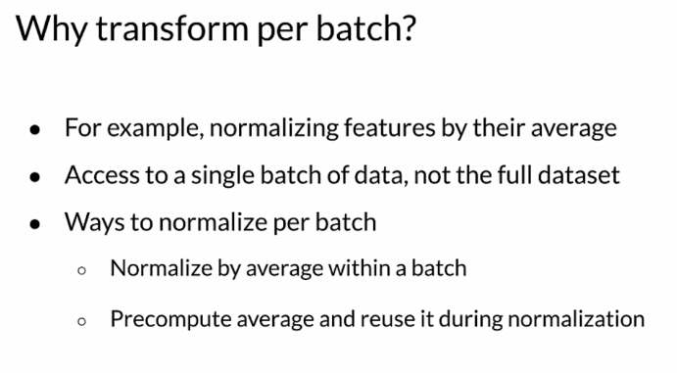

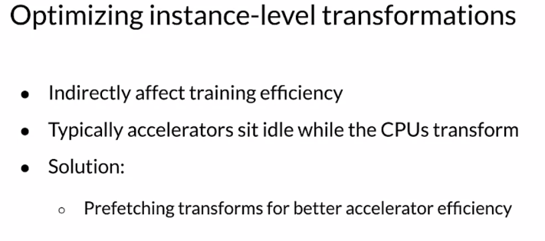

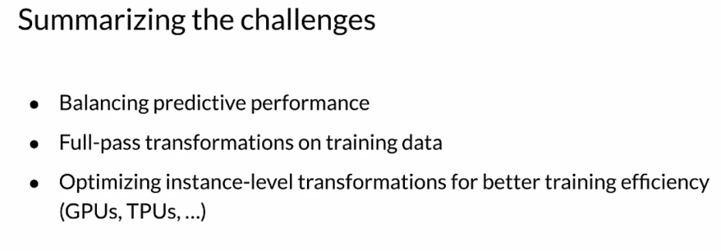

So to **summarize** the challenges we have to balance the predictive performance of our model and the requirements for it. Making full pass transformations on the training data is one thing. If we're going to do that then we need to think about how that works when we serve our model as well and save those constants. And we want to optimize the instance level transformations for better training efficiency. So things like prefetching can really help with that.

So **key points**, inconsistent data affects the accuracy of the results. So scalable data processing frameworks allow processing of large datasets and distributed inefficient ways. But we also need to think about how that gets applied in serving.

### TensorFlow Transform

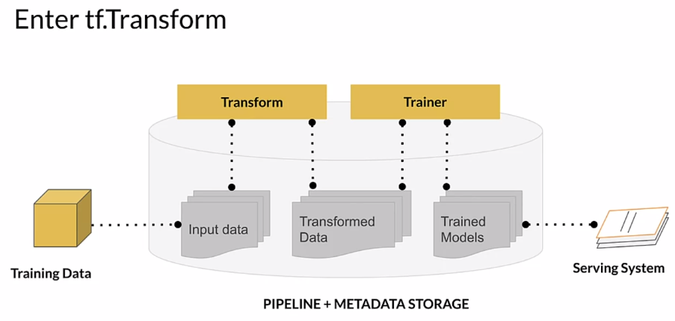

Looking at this a little differently, we're starting with our training and eval data. We've actually split our dataset. We split it with **ExampleGen**. Those get fed to **StatisticsGen**. These are both TFX components within a TFX pipeline. StatisticsGen calculates statistics for our data. For each of the features, if they're numeric features, for example, what is the mean of that feature value? What is the standard deviation? The min, the max, so forth. Those statistics get fed to **SchemaGen** which infers the types of each of our features. That creates a schema that is then used by downstream components including **Example Validator**, which takes those statistics and that schema, and it looks for problems in our data. We won't go into great detail here about the things that it looks for, but if we have examples that are the wrong type in a particular feature, so maybe we have an integer where we expected a float. Now, we're getting into **Transform**. Transform is going to take the schema that was generated on the original split dataset, and it's going to do our feature engineering. Transform is where the feature engineering happens. That gets given the **Trainer**, there's **Evaluator** that evaluates the results, a set of **Pusher** that pushes it to our deployment targets which is, however we're serving our models, so **TENSORFLOW SERVING**, or **JS**, or **LITE**, wherever it is that we're serving our model.

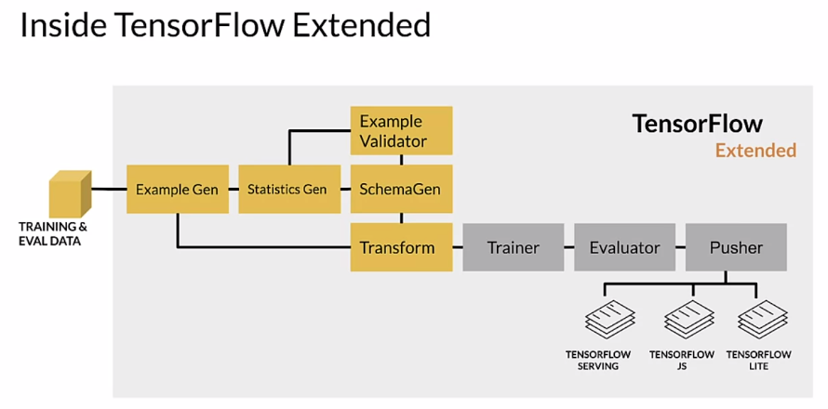

Internally, if we want to look at the transform component, it's getting inputs from, as we saw, ExampleGen and SchemaGen. That is the data that was originally split by Example Gen, and the schema that was generated by SchemaGen. That schema, by the way, may very well have been reviewed and improved by a developer who knew more about what to expect from the data than can be really inferred by SchemaGen. That's referred to as curating the schema. Transform gets that and it also gets a lot of user code because we need to express the feature engineering we want to do. If we're going to normalize a feature, we need to give it user code to tell transform to do that. The result is a TensorFlow graph, which was referred to as the transform graph and the transform data itself. The graph expresses all of the transformations that we are doing on our data, as a TensorFlow graph. The transform data is simply the result of doing all those transformations. Those are given to Trainer, which is going to use the transformed data for training and it's going to include the transform graph and we'll take a look at that in a second. We have a user provided transform component and we have a schema for it. We apply our transformations during training and as we'll see later, we also apply those transformations at serving time. There's a lot of performance optimizations that we apply as well, and we'll take a look at that in a second.

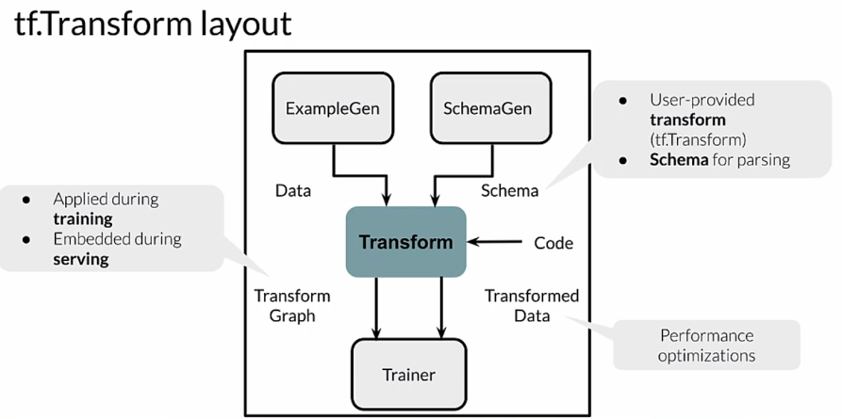

Continuing a little deeper here, we have our raw data and we have our transform component. It produces a TensorFlow graph. The result of running that graph is processed data, it's been transformed. That gets given in model training, as processed data is given to our trainer component, where we use it for training our model. Training our model creates a TensorFlow graph. Notice now we have two different graphs. We have a graph here from Transform and a graph here from Training. Using the Tf Transform API, we express the feature engineering that we want to do and we give that code, or rather the transform component gives that code to a Apache Beam distributed processing cluster. That way we can do, and remember this is all designed to work with potentially terabytes of data. That could be quite a bit of processing to do all of that transformation using a distributed processing cluster by using Apache Beam gives us the capacity to do that. The result is a saved model. Saved model is just a format that expresses a trained model as a saved model. That gets included, we have both the transform graph and the training graph. Those are given to our serving infrastructure. Now we have both of those graphs, the feature engineering that we did, and the model itself, the trained model and those are used when we serve requests.

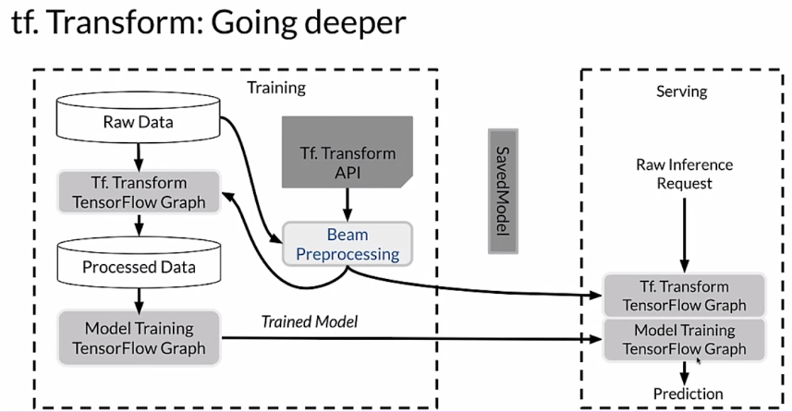

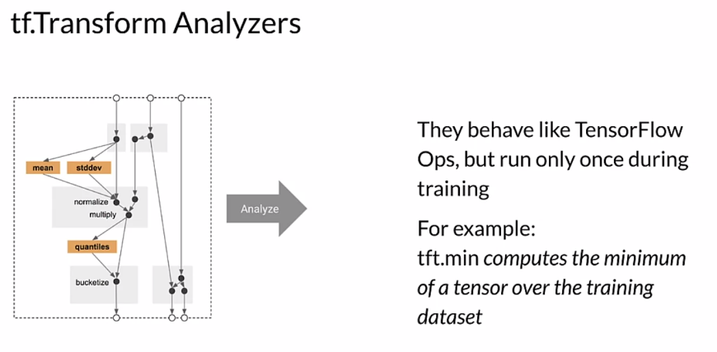

Looking at this a little differently, we have analyzers. Again, we're using TensorFlow and we're using the TensorFlow Transform API. We're using TensorFlow Ops and a big part of what they do, what an Analyzer does is it makes a full pass over our dataset in order to collect constants that we're going to need when we do feature engineering. For example, if we're going to do a min-max, well, we need to make a full pass through our data to know what the min and the max are for each feature that we're using for that. Those are constants that we need to express. We're going to use an Analyzer to make that pass over the data and collect those constants. It's also going to express the operations that we're going to do. They behave like TensorFlow Ops, but they only were on once during training and then they're saved off as a graph. For example, if we're using the tft.min, which is one of the methods in the transform STK, it'll compute the minimum of a tensor over the training dataset.

Looking at how that gets applied, we have the graph that is our feature engineering. We run an analysis across our dataset to collect the constants that we need. Really what we're doing is we're enabling us later to apply these into our Transform graph, so that we can transform individual examples without making a pass over our entire dataset. That gets applied during training, and the same exact graph gets applied during serving. There is no potential here for training and serving skew or having different code paths when we train our model versus when we serve our model that causes problems and those not be equivalent. We're using exactly the same graph in both places, so there is no potential for doing that.

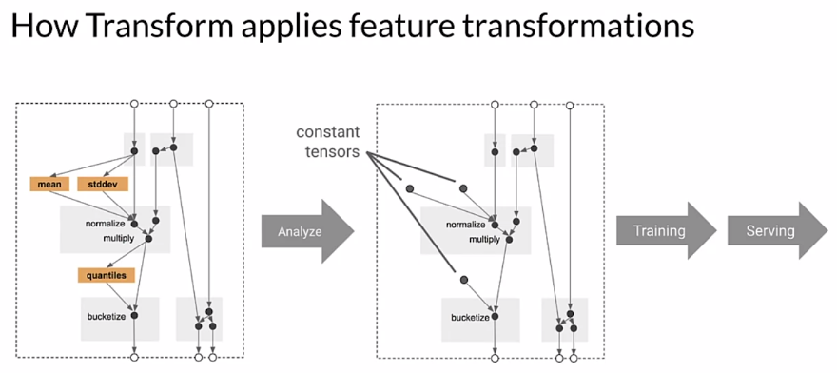

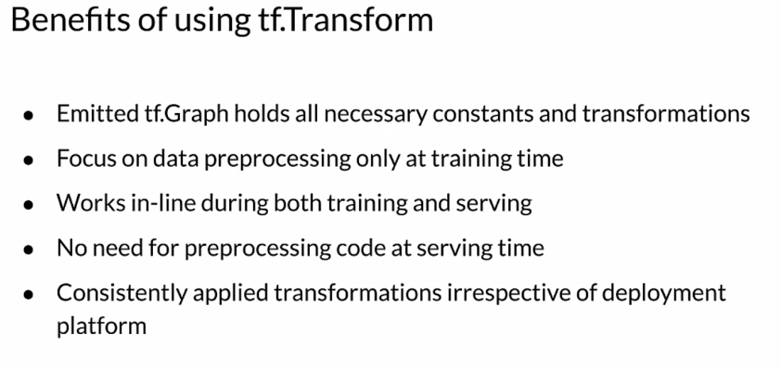

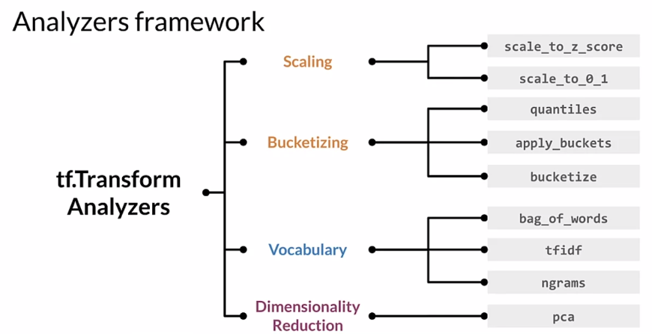

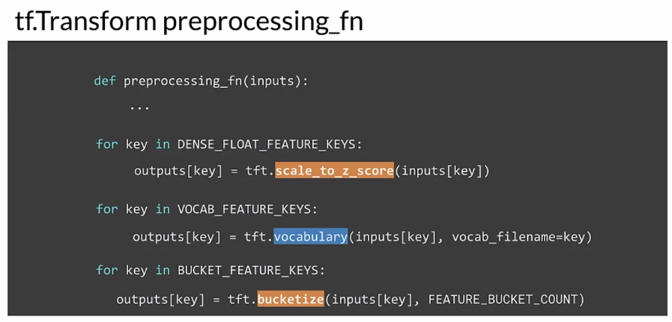

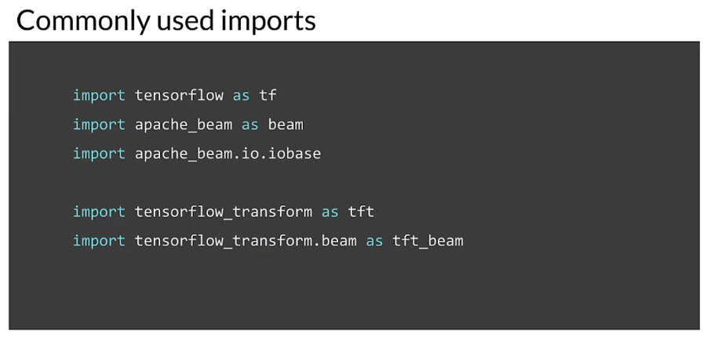

### Hello World with tf.Transform

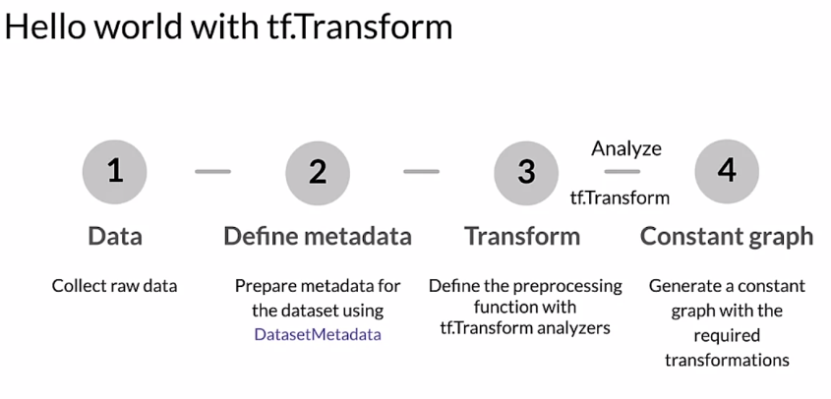

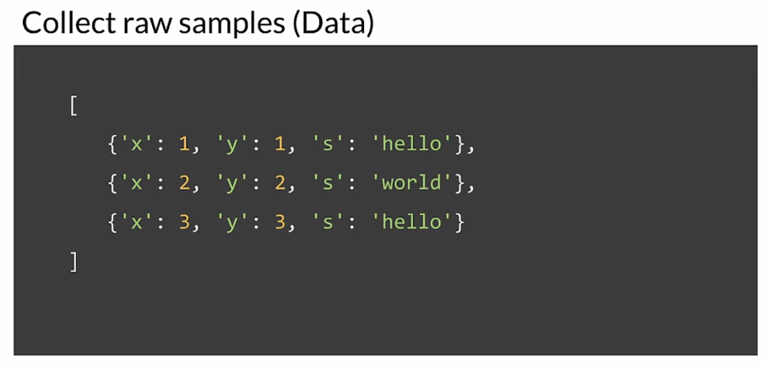

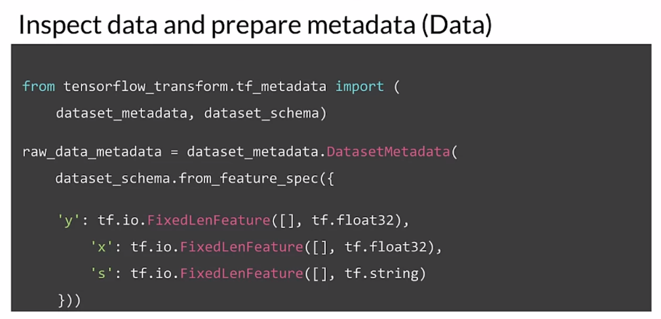

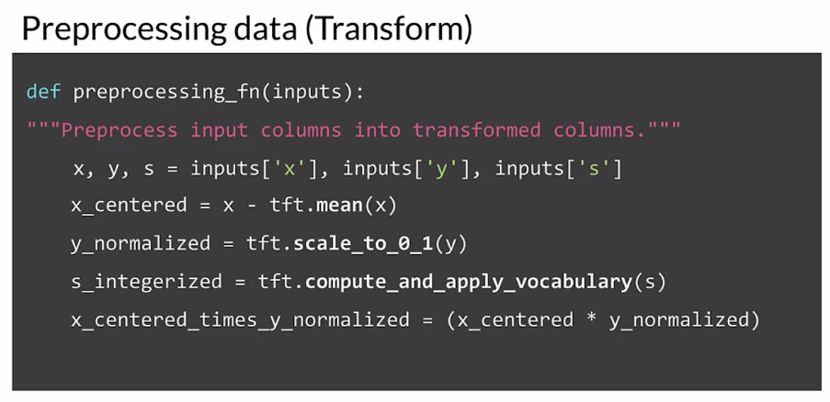

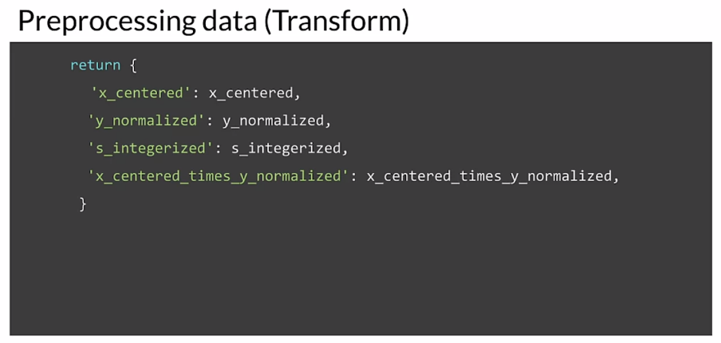

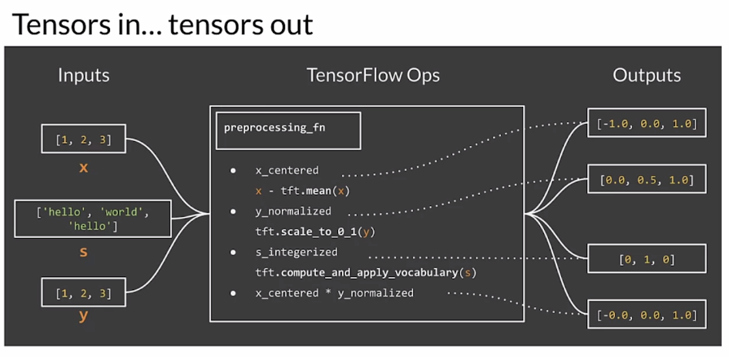

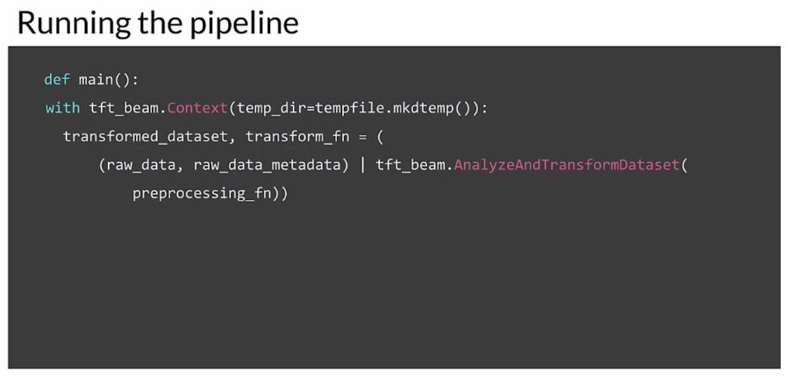

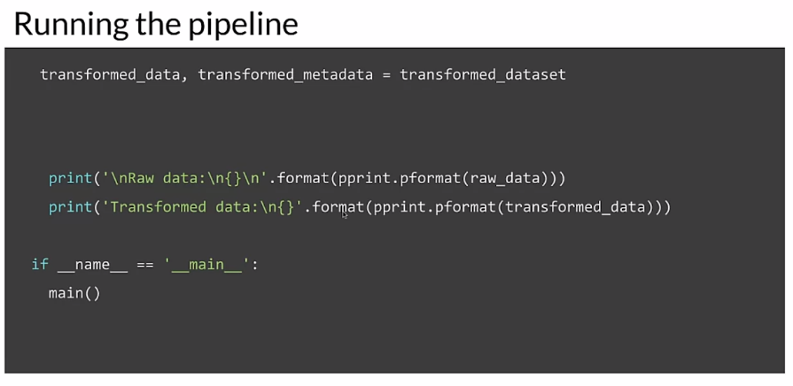

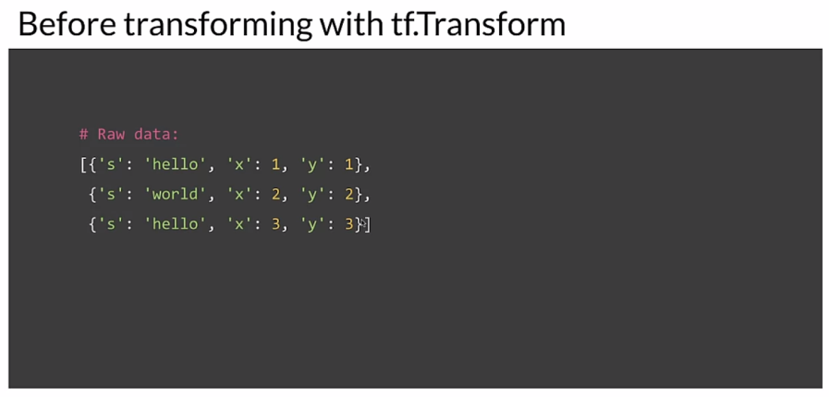

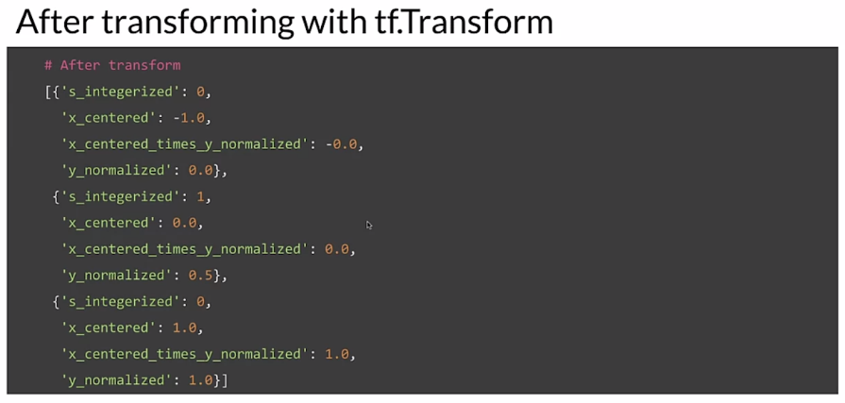

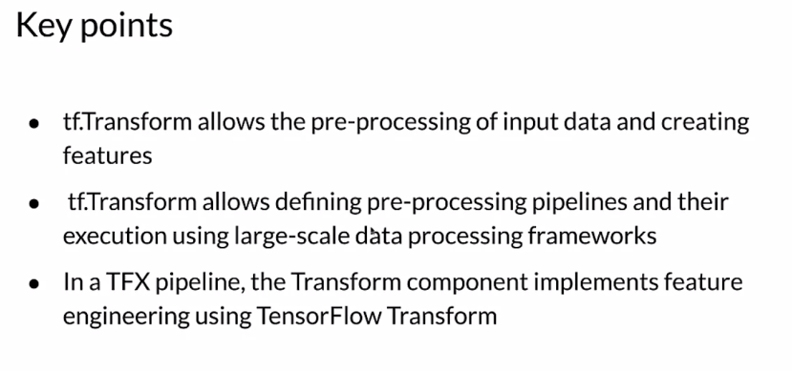

## Feature Selection

### Feature Spaces

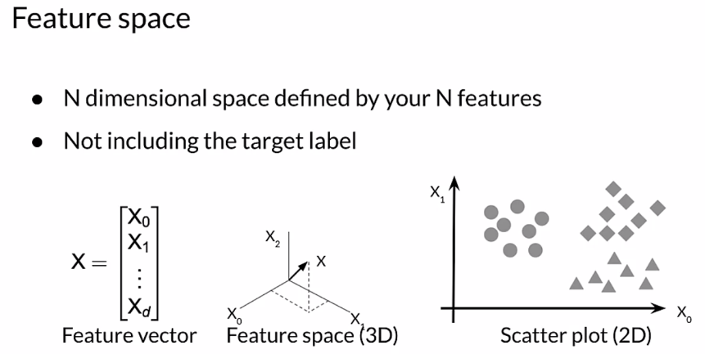

Let’s see an example of house pricing.

### 

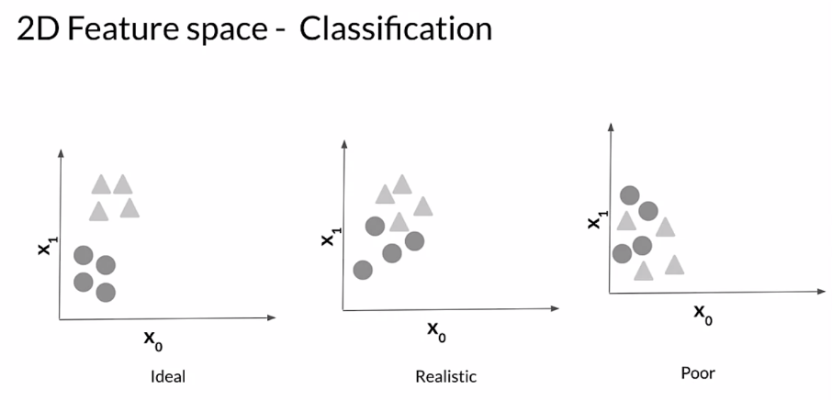

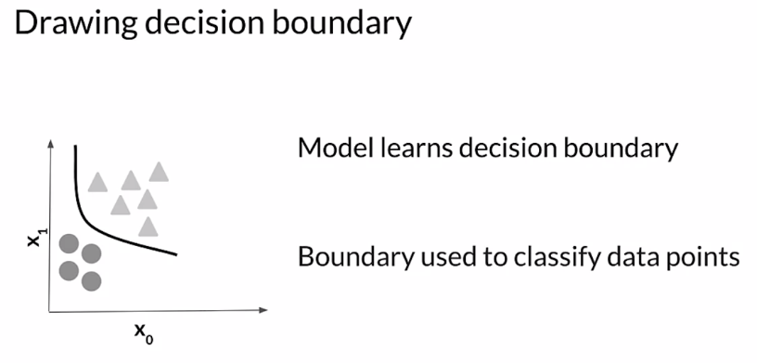

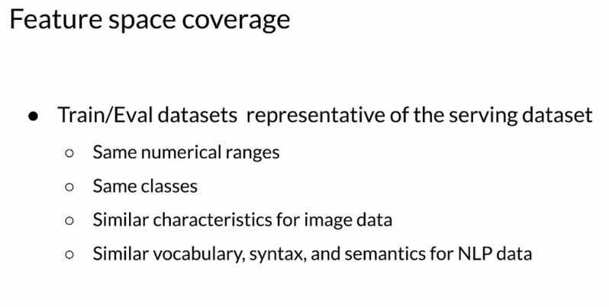

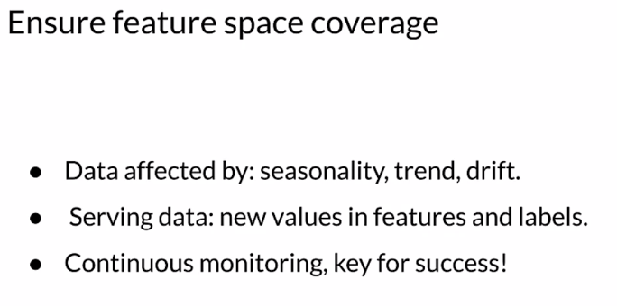

### Feature Selection

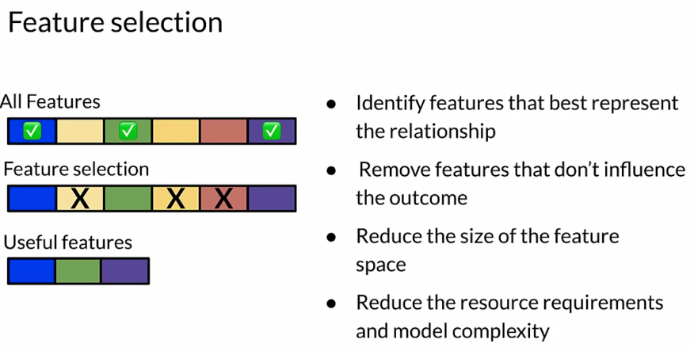

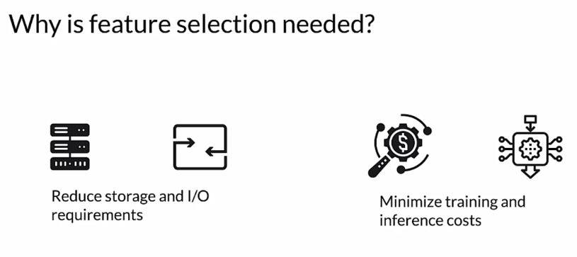

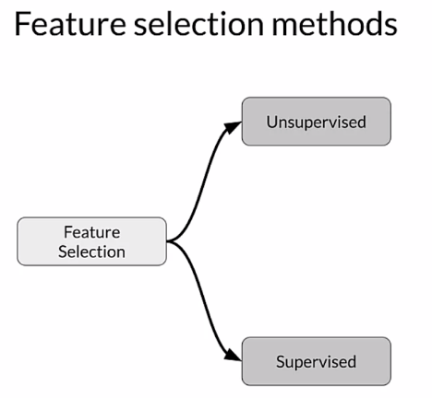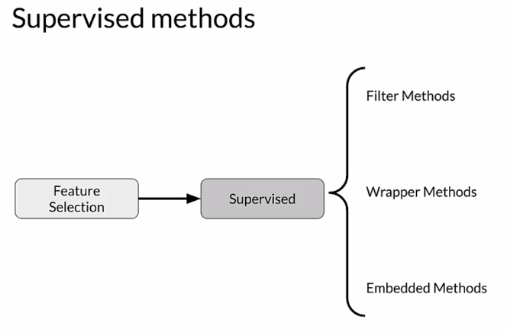

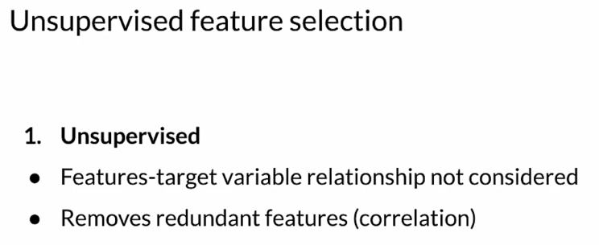

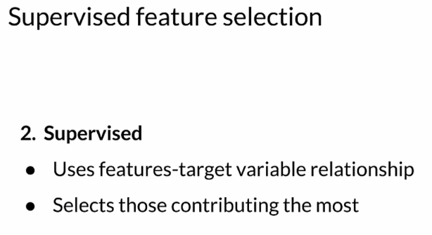

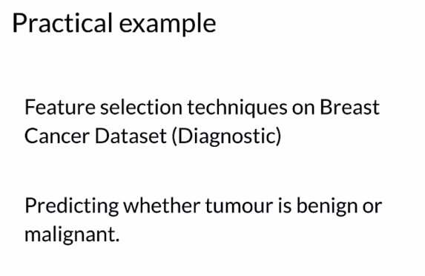

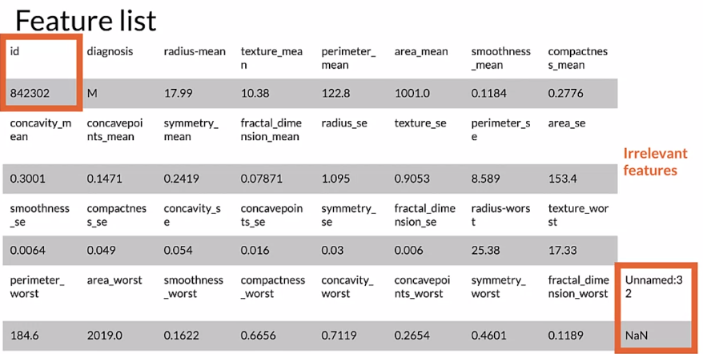

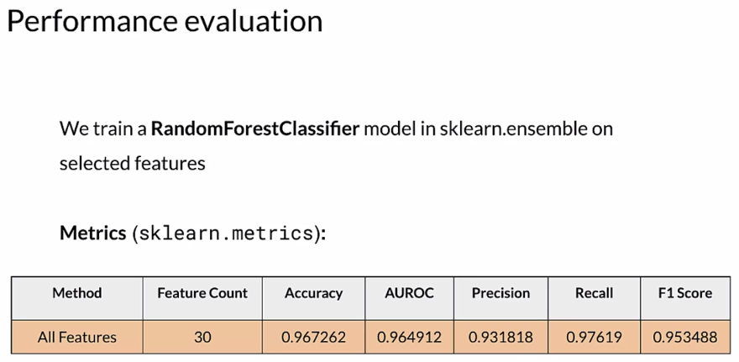

### Filter Methods

#### 

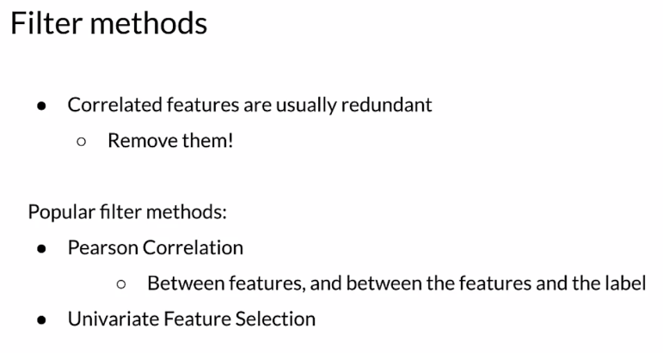

#### 

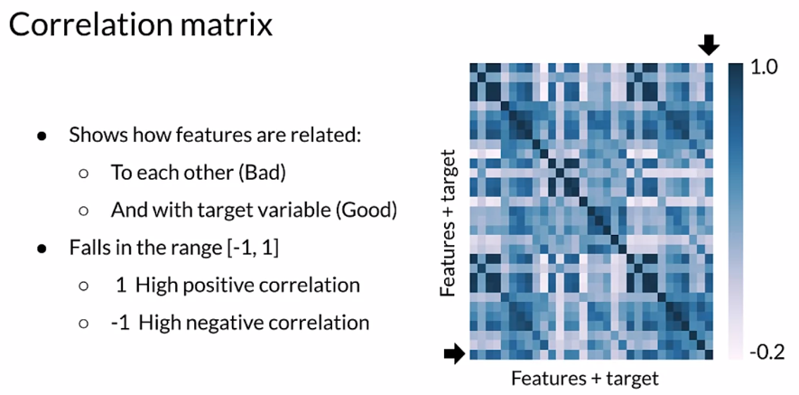

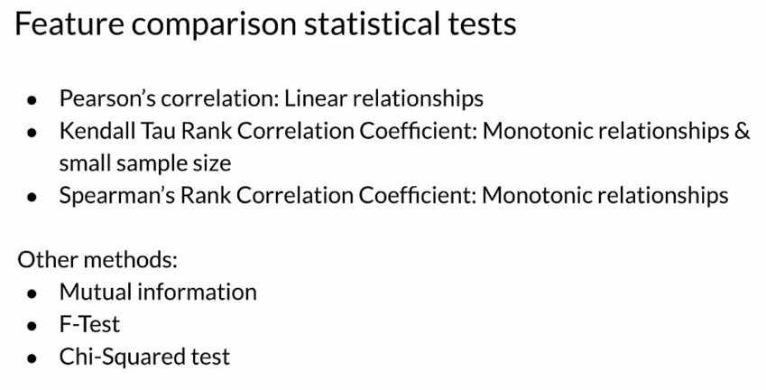

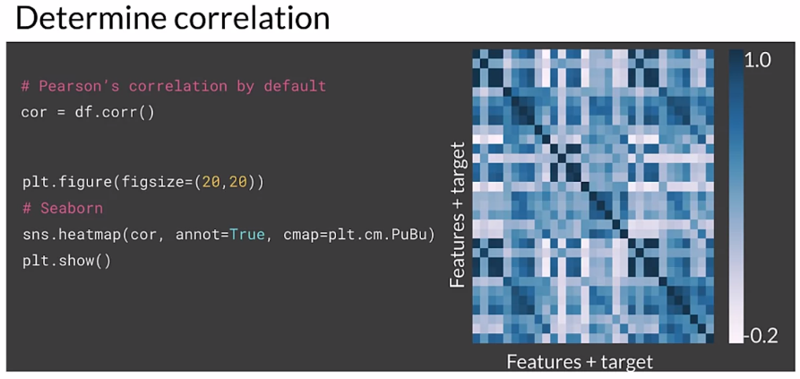

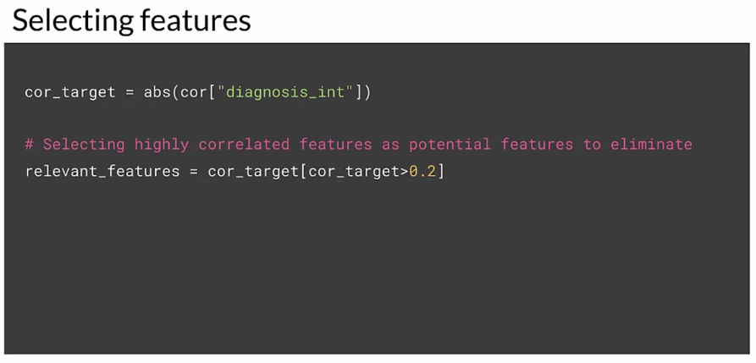

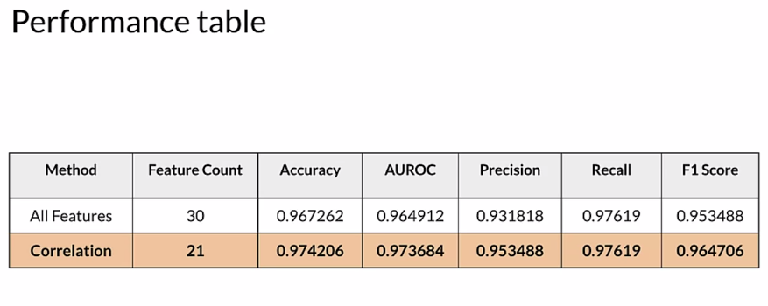

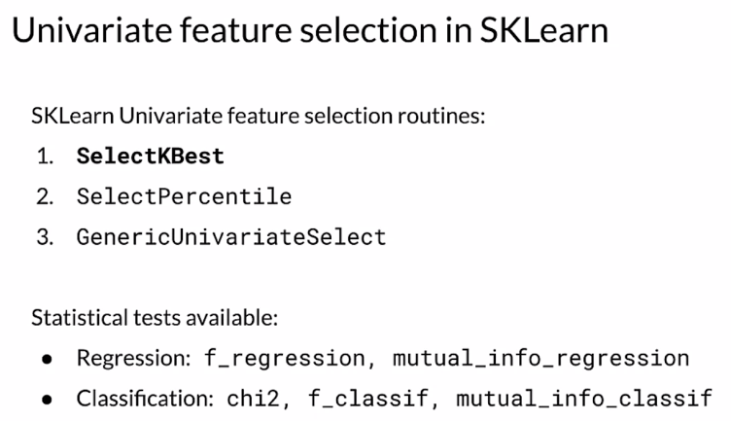

There is a bug in standardizing **X_test** here and in some of the next videos. It should be transformed using the parameters computed from **X_train** . You will see this correction in the ungraded lab at the end of this lesson.

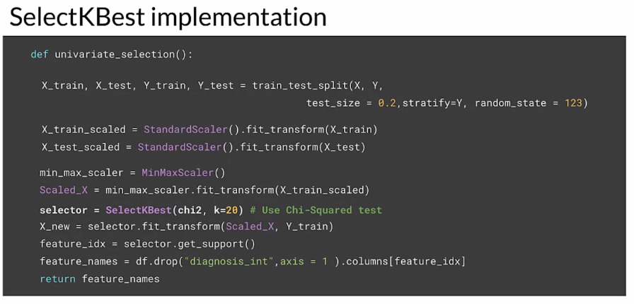

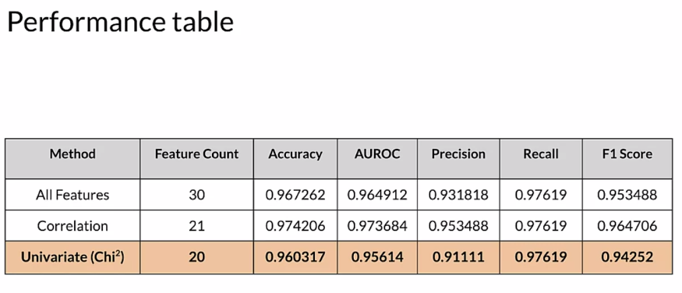

### Wrapper Methods

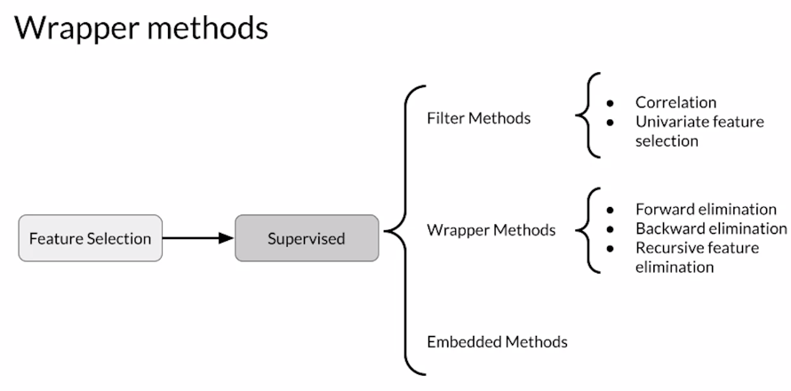

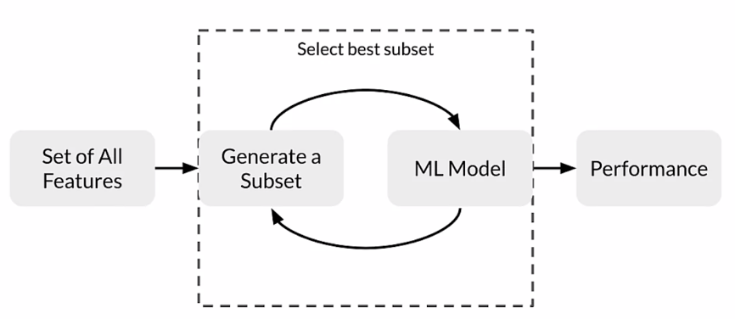

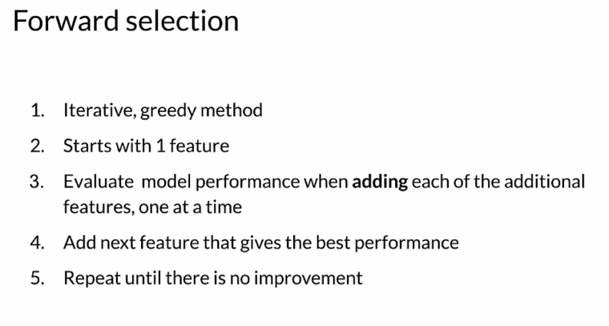

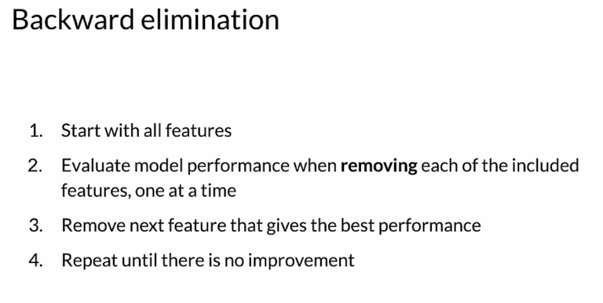

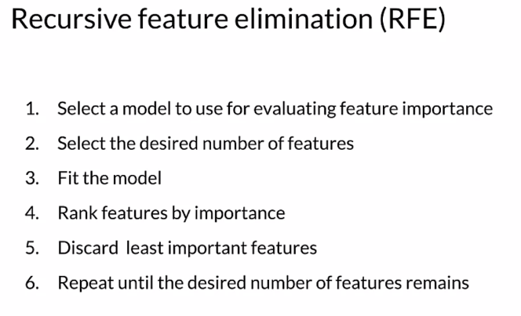

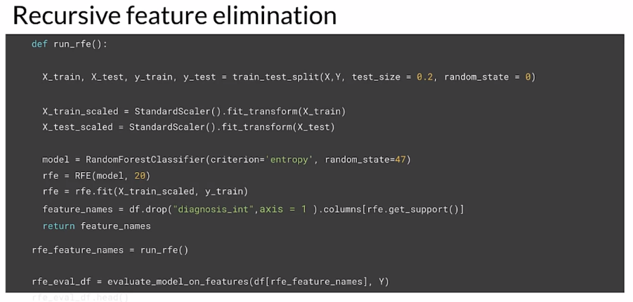

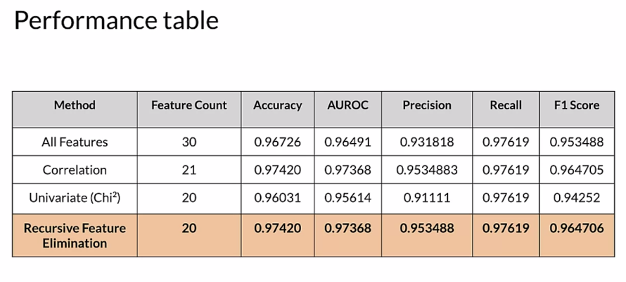

### Embedded Methods

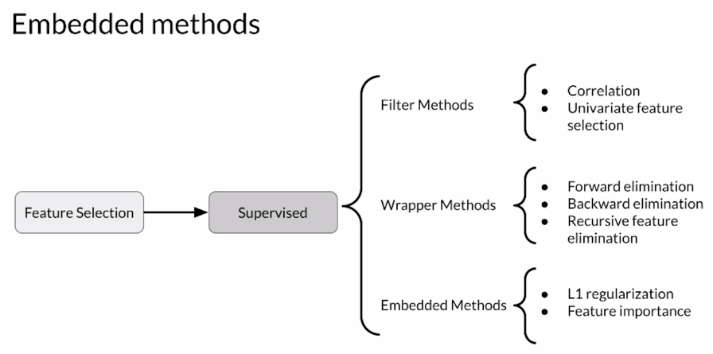

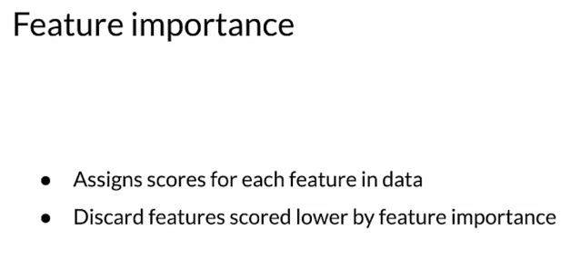

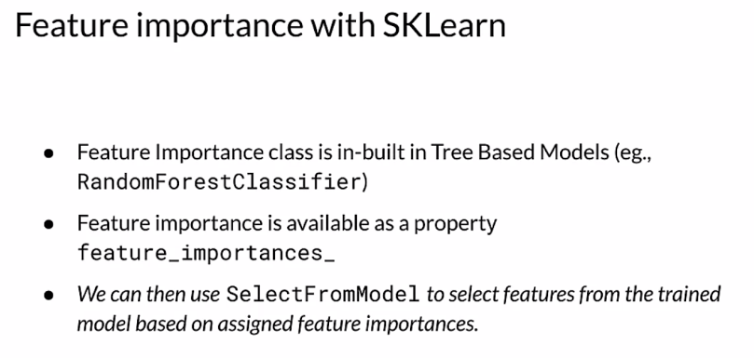

#### 

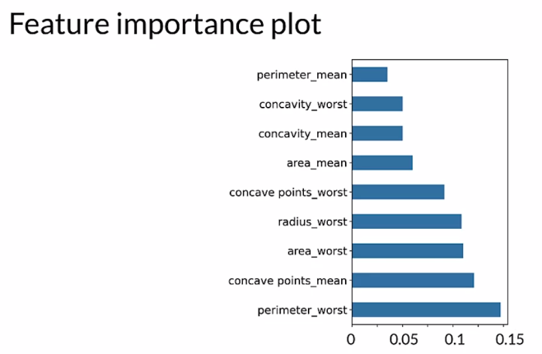

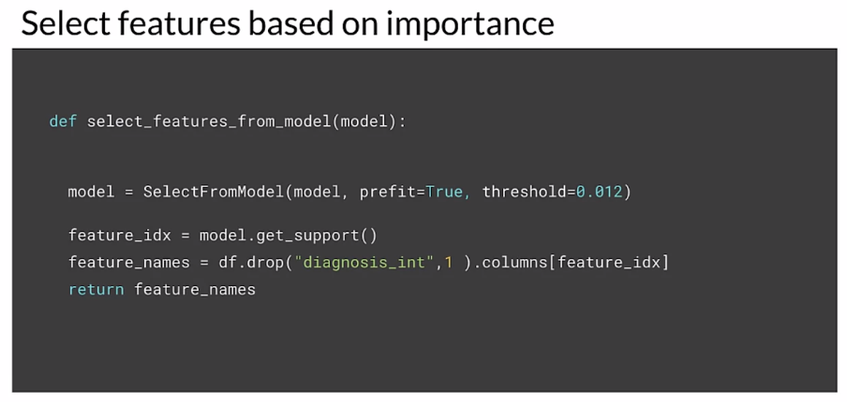

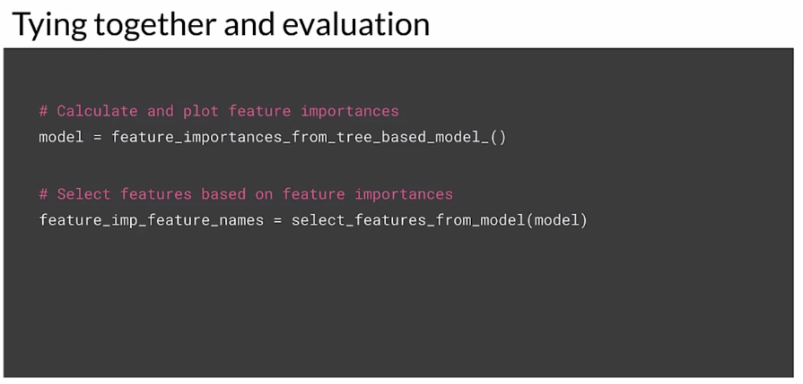

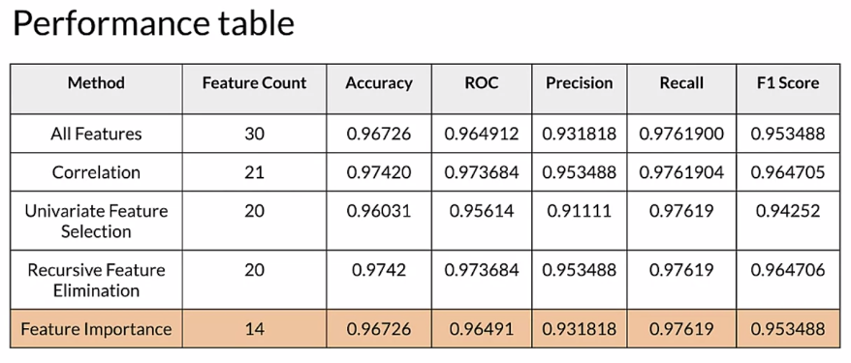

Embedded methods combine the best of both worlds, filter and wrapper methods:

* Faster than wrapper methods: Wrapper methods are based on the greedy algorithm and thus solutions are slow to compute.
* More efficient than filter methods: Filter methods suffer from inefficiencies as they need to look at all the possible feature subsets.

## Week 2 Optional References

Week 2: Feature Engineering, Transformation and Selection

If you wish to dive more deeply into the topics covered this week, feel free to check out these optional references. You won’t have to read these to complete this week’s practice quizzes.

[Mapping raw data into feature](https://developers.google.com/machine-learning/crash-course/representation/feature-engineering)

[Feature engineering techniques](https://www.commonlounge.com/discussion/3ce75d036e924c70ab7e47f534ec40fc/history)

[Scaling](https://raw.githubusercontent.com/jbrownlee/Datasets/master/shampoo.csv)

[Facets](https://pair-code.github.io/facets/)

[Embedding projector](http://projector.tensorflow.org/)

[Encoding features](https://developers.google.com/machine-learning/crash-course/feature-crosses/encoding-nonlinearity)

TFX:

1. <https://www.tensorflow.org/tfx/guide#tfx_pipelines>
2. <https://ai.googleblog.com/2017/02/preprocessing-for-machine-learning-with.html>

[Breast Cancer Dataset](http://archive.ics.uci.edu/ml/datasets/breast+cancer+wisconsin+%28diagnostic%29)

# Week 3: Data Journey and Data Storage

## Data Journey and Data Storage

### Data Journey

Trying to understand data provenance begins with the Data journey. The journey starts with raw features and labels from whatever sources that we have. The Data describes a function that maps the input in the training set to the labels that we're trying to predict. During training, the model learns the functional mapping from the input to the labels so as to be as accurate as possible. The Data transforms and changes as part of this training process.

### 

The Data transforms and changes as part of this training process. As the Data flows through the process it transforms. Examples of this are, are changing data formats, applying feature engineering and training the model to make predictions. There's a dual connection between understanding these data transformations and interpreting the model's results. Therefore, it's important to track and document these changes closely.

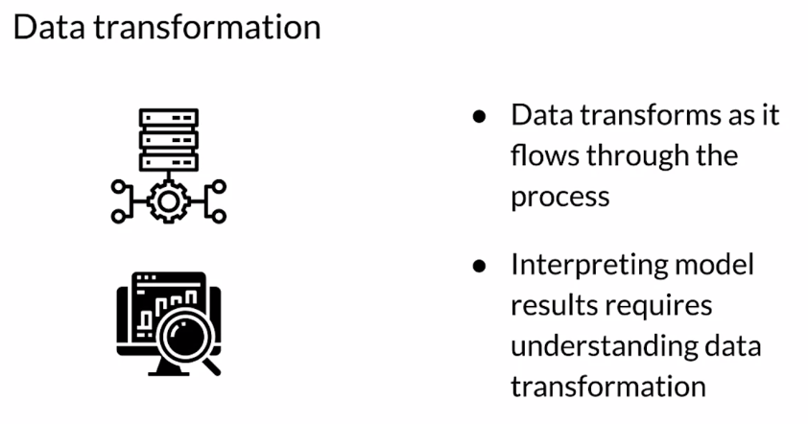

Data artifacts are created as pipeline components execute. What exactly is an artifact? Each time a component produces a result, it generates an artifact. This includes basically everything that is produced by the pipeline, including the data in different stages of transformation, often as a result of feature engineering and the model itself and things like the schema, and metrics and so forth. Basically, everything that's produced, every result that is produced as an artifact.

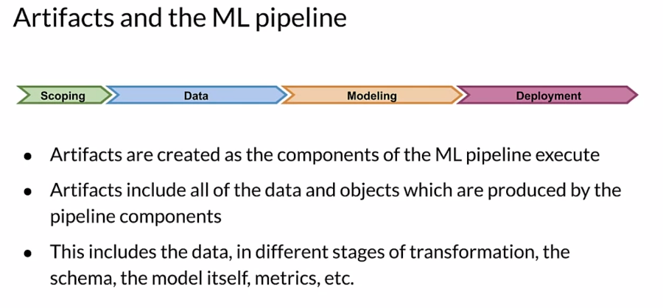

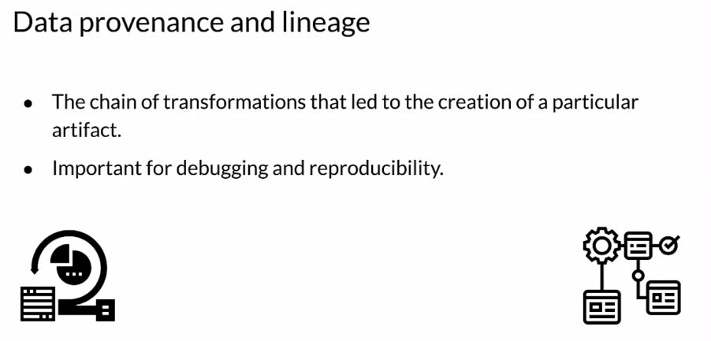

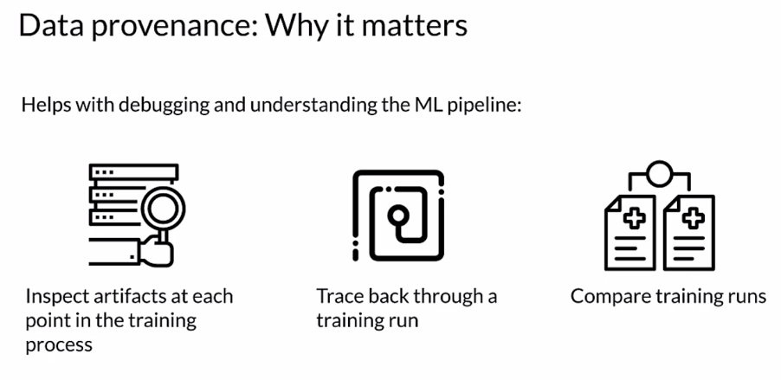

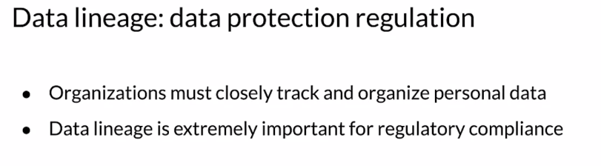

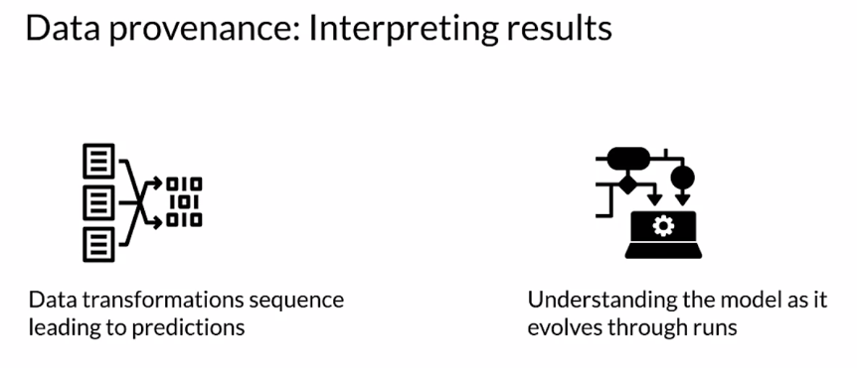

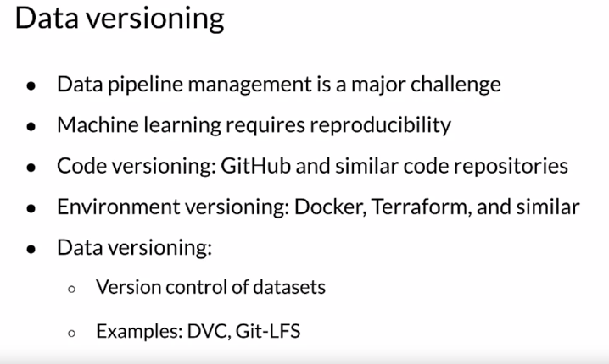

### Introduction to ML Metadata

Now let's start exploring how ML metadata or MLMD can help you with tracking artifacts and pipeline changes during a production life cycle. Every run of a production ML pipeline generates metadata containing information about the various pipeline components and their executions or training runs and the resulting artifacts. For example, trained models. In the event of unexpected pipeline behavior or errors, this metadata can be leveraged to analyze the lineage of pipeline components and to help you debug issues. Think of this metadata as the equivalent of logging in software development. MLMD helps you understand and analyze all the interconnected parts of your ML pipeline, instead of analyzing them in isolation.

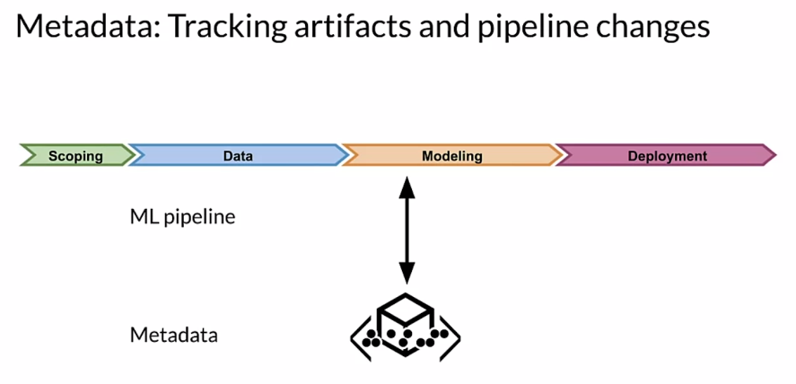

Now consider the two stages in ML engineering that you've seen so far. First you've done data validation, then you've passed the results onto data transformation or feature engineering. This is the first part of any model training process.

But what if you had a centralized repository where every time you run a component, you store the result or the update or any other output of that stage into a repository. So whenever any changes are made, which causes a different result, you don't need to worry about the progress you've made so far getting lost. You can examine your previous results to try to understand what happened and make corrections or take advantage of improvements.

#### 

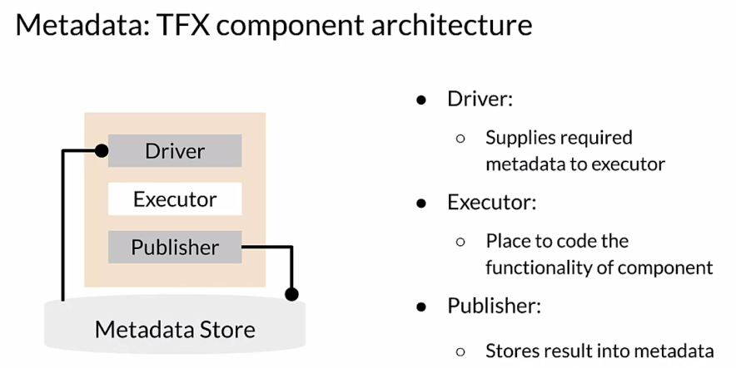

Let's take a closer look. In addition to the executor where your code runs, each component also includes two additional parts, the **driver** and **publisher**. The **executor** is where the work of the component is done and that's what makes different components different. Whatever input is needed for the executor, is provided by the driver, which gets it from the metadata store. Finally, the publisher will push the results of running the executor back into the metadata store. Most of the time, you won't need to customize the driver or publisher. Creating custom components is almost always done by creating a custom executor.

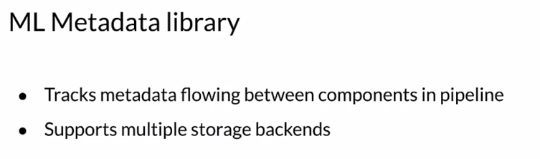

Now, let's look specifically at ML Metadata or MLMD. MLMD is a library for tracking and retrieving metadata associated with ML developer and data scientist workflows. MLMD can be used as an integral part of an ML pipeline or it can be used independently. However, when integrated with an ML pipeline, you may not even explicitly interact with MLMD. Objects which are stored in MLMD are referred to as artifacts. MLMD stores the properties of each artifact in a relational database and stores large objects like data sets on disc or in a file system or block store.

When you're working with ML metadata, you need to know how data flows between different successive components. Each step in this data flow is described through an entity that you need to be familiar with. At the highest level of MLMD, there are some data entities that can be considered as **units**.

First, there are artifacts. An artifact is an elementary unit of data that gets fed into the ML metadata store and the data is consumed as input or generated as output of each component. Next there are executions. Each execution is a record of any component run during the ML pipeline workflow, along with its associated runtime parameters. Any artifact or execution will be associated with only one type of component. Artifacts and executions can be clustered together for each type of component separately. This grouping is referred to as the context. A context may hold the metadata of the projects being run, experiments being conducted, details about pipelines, etc. Each of these units can hold additional data describing it in more detail using properties. Next there are **types**, previously, you've seen several types of units that get stored inside the ML metadata. Each type includes the properties of that type. Lastly, we have **relationships**. Relationships store the various units getting generated or consumed when interacting with other units. For example, an event is the record of a relationship between an artifact and an execution.

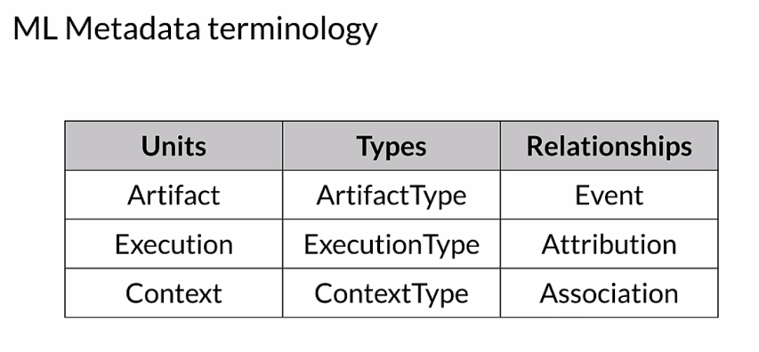

So, ML metadata stores a wide range of information about the results of the components and execution runs of a pipeline. It stores artifacts and it stores the executions of each component in the pipeline. It also stores the lineage information for each artifact that is generated. All of this information is represented in metadata objects and this metadata is stored in a back end storage solution.

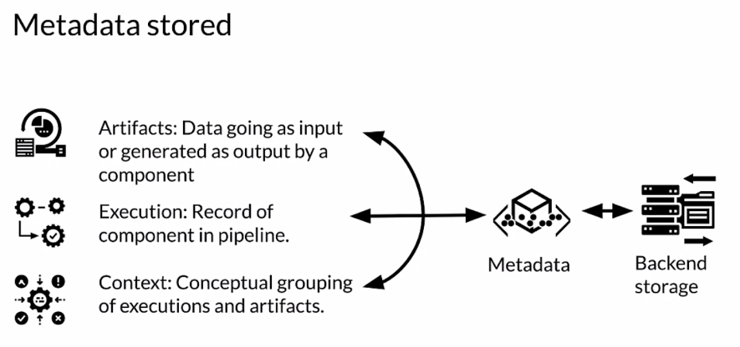

Let's take a look at the architecture of ML metadata or MLMD. On the top are the various components present in any ML pipeline. All of these components are individually connected to a centralized metadata store of ML metadata, so that each component can independently access the metadata at any stage of the pipeline.

An ML pipeline may optionally have a gooey console that can access the data from the metadata store directly to track the progress of each component. At the heart of the metadata store is the artifact which is described by its corresponding artifact type. Artifacts become the inputs to any pipeline components which depend on them. And the corresponding use of artifacts by components is recorded in executions. The input of an artifact into a component is described by an input event and the corresponding output of a new artifact from the component is described by an output event. This interaction between artifacts and executions is represented by context through the relationships of attribution and association. Lastly, all of the data generated by the metadata store is stored in various types of back end storage like sequel light and my sequel and large objects are stored in a file system or block store.

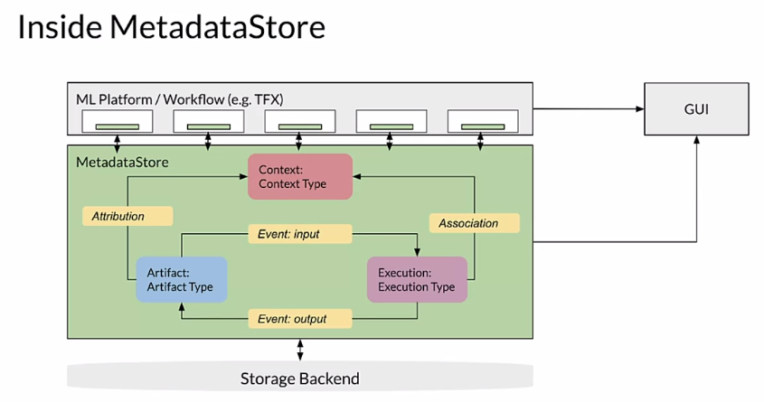

You learned a lot about the architecture and nomenclature of ML metadata or MLMD and the artifacts and entities which it contains. This should give you some idea of how you can leverage MLMD to track metadata and the results flowing through your pipeline to better understand your training process, both now and in previous training runs of your pipeline.

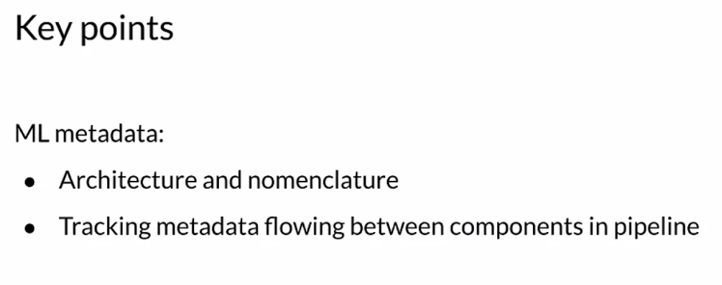

### ML Metadata in Action

Besides data lineage and provenance tracking, you get several other benefits through ML Metadata. This includes the ability to construct a directed acyclic graph or DAG, of the component executions occurring in a pipeline, which can be useful for debugging purposes. Through this, you can verify which inputs have been used in an execution. You can also summarize all the artifacts belonging to a specific type generated after a series of experiments. For example, you can list all of the models that have been trained. You can then compare them to evaluate your various training runs.

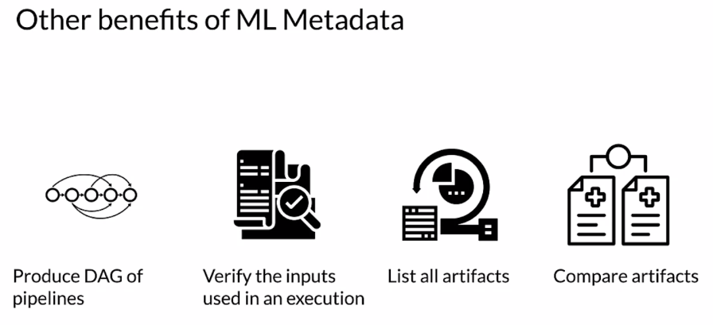

You may have to install ML Metadata, which you can do using PIP as shown here. Then there are two imports from ML Metadata which are used frequently, the ML Metadata store itself and the ML Metadata store PB2, which is a protocol buffer or protobuf.

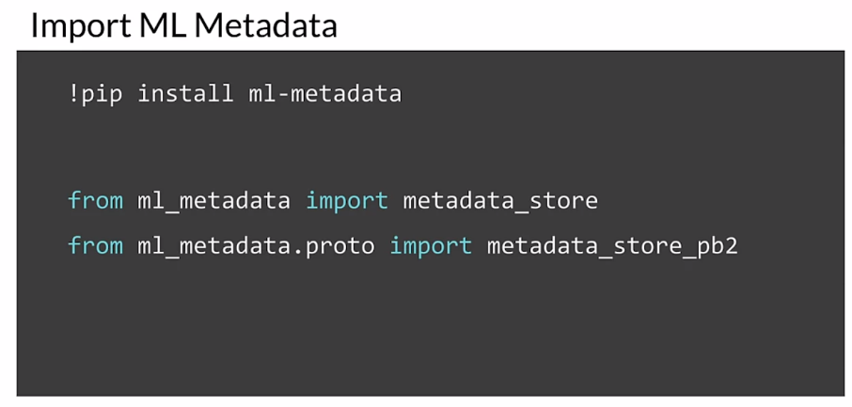

Start by setting up the storage backend. ML Metadata store is the database where ML Metadata registers all of the metadata associated with your project. ML Metadata provides APIs to connect with a fake database for quick prototyping, SQLite and MySQL. We also need a block store or file system where ML Metadata stores large objects like datasets.

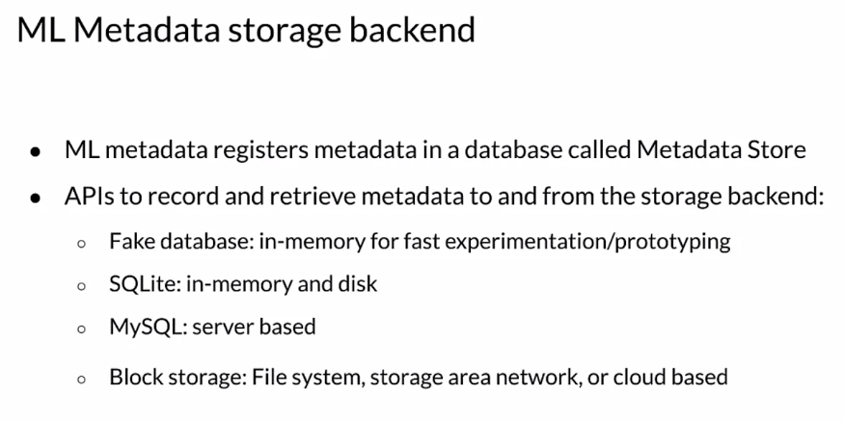

Let's quickly explore the first three options. For any storage backend, you'll need to create a connection config object using the metadata store PB2 protobuf. Then, based on your choice of storage backend, you need to configure this connection object. Here you're signaling that your fake database is in parent, which is the primary memory of the system on which it's running. Finally, you create the store object passing in the connection config. Regardless of what storage or database you use, the store object is a key part of how you interact with ML Metadata.

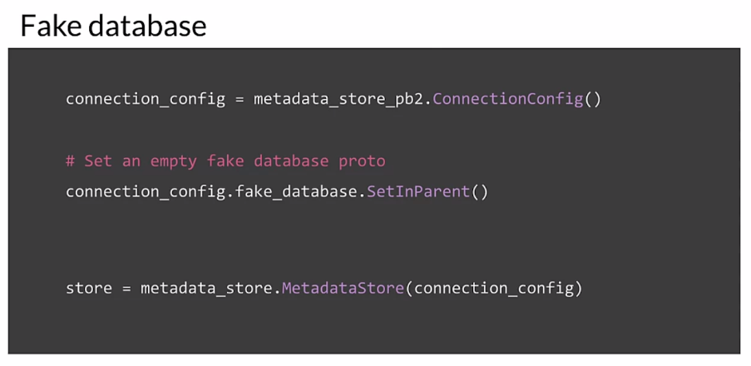

To use SQLite, you start by creating a connection config again then you configure the connection config object with the location of your SQLite file. Make sure to provide that with the relevant read and write permissions based on your application. Finally, you create the store object passing in the connection config.

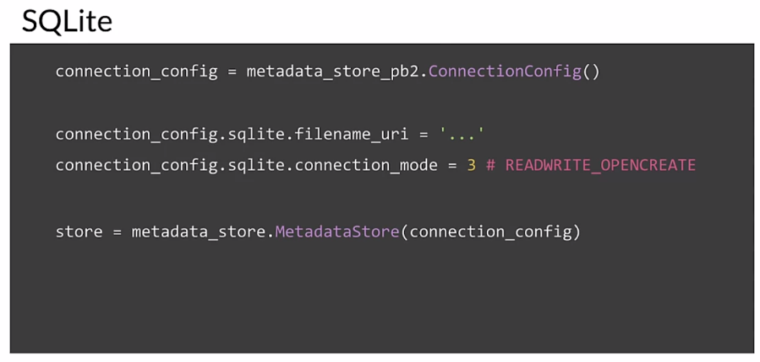

As you might imagine, using MySQL is very similar, you start by creating a connection config. Your connection config object should be configured with the relevant host name, the port number, the database location, username, and password of your MySQL database user and that's shown here. Finally, you create the store object passing in the connection config.

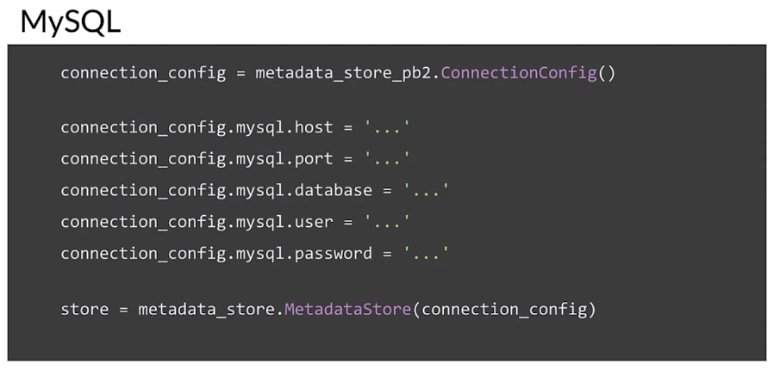

Let's review the key points which we covered in this lesson. First, you learned about data lineage and provenance to address data evolution over the ML Pipeline lifecycle. Then you went over metadata for tracking those data changes. Then you inspected the architecture of the ML Metadata library. Finally, in the ungraded lab, you read an example to register artifacts, executions, and contexts.

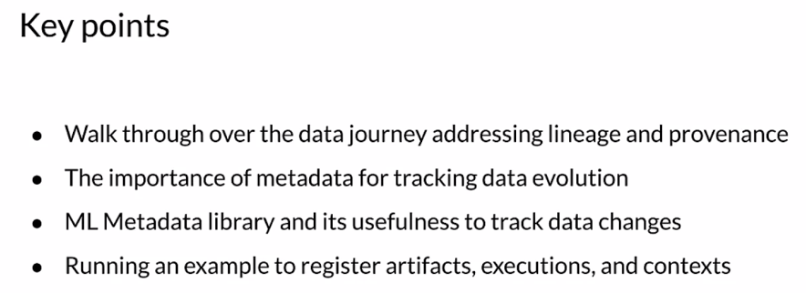

## Evolving Data

## Enterprise Data Storage

# 